

Macroeconomics 2



Jihočeská univerzita v Českých Budějovicích
Branišovská 1645/31a
370 05 České Budějovice
IČ: 60076658

Obsah
Obsah 1
1 The 4 sectors of economics 3
1.1 The influence of the state 4
1.2 Keynes's General Theory 6
1.3 Concept of effective demand 7
1.4 Keynesian Linear Consumption Function 7
1.5 Conclusion 9
2 Consumption function 10
2.1 Consumption function 10
2.2 The determinants of consumption 12
2.3 Consumption function 13
2.4 Saving function 13
2.5 Consumption curves – graphs 15
2.6 Summary 19
3 The AD-AS model 20
3.1 Aggregate demand 20
3.2 Aggregate supply 23
3.3 Interpreting the AD/AS model 25
3.4 Summary 26
4 Money market 27
4.1 Money market – definition and function 27
4.2 Participants on the money market 28
4.3 Money market instruments 28
Short-term loans 28
4.4 Short-term government securities 30
4.5 The exchange rate 31
4.6 Effective nominal exchange rate 32
4.7 Real exchange rate 32
4.8 Summary 34
5 Aggregate supply 36
5.1 Short run aggregate supply (SRAS) 37
5.2 Summary 39
6 Investments (Macroeconomics approach) 40
7 Inflation and fiscal policy 43
7.1 Inflation Introduction 43
7.3 Inflation rate calculation 46
7.4 Fiscal policy 47
7.5 Fiscal policy 47
8 The new growth model theory 51
9 Real business cycle theory 56
9.1 Business cycles 57
9.2 Real business cycle theory 58
9.3 Examples of Real business cycle theory 59
9.4 Critical Reflection on Real Business Cycle theory 61
10 Lucas curve model 63
List of references 66

The 4 sectors of economics
But before we begin our study of Keynesianism, I would like to tell that this theory is mainly applicable to some sectors of the economy. This division of the economy by sectors is posterior to Keynes. It was first developed by another British economist; Colin Clark in his book “The conditions of economic progress” in the year 1947. At that time he split the economy in only 3 sectors. The fourth one was added later on by other economists and was a split of the third one.
- primary sector: production of non transformed goods (ex: agriculture, fishery, …)
- secondary sector: transformation of the goods produced by the primary sector in consumption goods (ex: industries)
- tertiary sector: services to the people (ex: restaurant, bank, insurance, etc.). It represents the major part of the actual economy.
- quaternary sector: It is including some activities that were earlier part of the tertiary sector. It has really different definitions according to the different economists that worked on it. Some of them include just the high technology research and development, while some others include all sectors except the ones providing people care services1.

The influence of the state
The action of the State is one of the main points of Keynes theory. And it is much more important than in the classical theory of economics.
We have to know that the production of goods and services are really important for the economy. The most goods and services are produced, the highest is the GDP. As the GDP is often used as one of the main indicators for the economic health of a state, it is important to have a high production of goods and services.
The production of goods and services is calculated by the sum of the consumption, the investment, the purchase of the state and the export. This calculation is really important in the world of economics.
Sometimes, the market is facing a recession or even worse, a crisis. In those conditions, the economic growth is slowing down or decreasing. During those times the consumption, the investment and the export are decreasing (sometimes just one or two of those 3 parameters are decreasing). In that case, the production of goods and services is decreasing. It often leads to a vicious circle because the decrease in the production of goods and services leads to a decrease of consumption, investment and export.
But there is still one parameter we didn't talk about: the purchase of the state. This last economical parameter is the one that is important for Keynes theory. According to Keynes, when the economic activity is slowing down, the intervention of the State is the only way to stimulate the economic activity and to overcome the economic crisis². And the best way for the state to stimulate the economy is to increase his own purchase. Those investments of the state are, according to Keynes, necessary to guarantee the production of goods and services and thereby the economic health of the state.
But as you can imagine, the State has to find money in order to stimulate the economy. The State can not increase the taxes, because it would increase the constraint on the investment and slow it down, what would be counterproductive. The increase in the taxes would also slow the consumption because the households purchasing power would have decreasde (because of the highest taxes). So the solution that Keynes suggest is to increase the public debt. By increasing its deficit, the State has some more money and can invest it into the economy (by financing some major infrastructures projects such as highways or airports that can launch the economy) in order to stimulate it. After some time the consumption, the investment and the export are increasing again. Then the State doesn't need to keep investing as much as before and can reduce his investment. Because the economy is getting better as during the crisis, the State earns more money with the taxes (even if the rate of the taxes didn't increase). But those incomes are most of the times not sufficient to refund the deficit of the State. Because the economy is getting better, the State can increase the taxes. It has to be reasonable in order to avoid a new economic crisis. This increase in the taxes also has a second benefit because it is avoiding a too high inflation (who could have some terrible economic consequences). Then the phenomenon is considered as the stabilisation of the economy.

Picture 2 : Keynesian economics
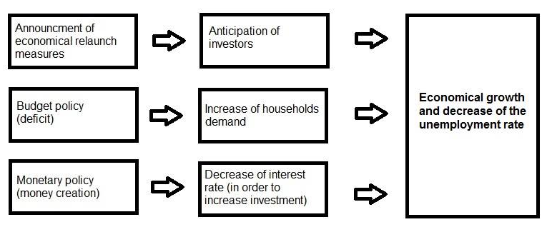
source: http://groupetpe1.e-monsite.com/pages/b-les-keynesiens.html
John Maynard Keynes also developed a tool that was inspired to him by Richard Kahn. According to Keynes, the relation between the investment of the State and the growth of the economy (the used indicator is the GDP) can be measured. The so called Keynesian multiplicator is the rate between the investment of the state and the growth of the GDP. If the State invest 1 000 000 Kc and that the GDP is then growing of 2 000 000 Kc, the Keynesian multiplicator is equal to 2. This tool is really efficient to calculate the efficiency of the policies leads by the states.
We have seen in the last paragraph that we can not neglect the influence of the State on the economy. But Keynes theory is not totally anti-liberal. Keynesianism defend the idea that that the markets can regulate themselves in some ways. It explains that they have to lead the economy but the state has to keep an eye on it and to intervene if necessary. The intervention of state has to be set up only when the market adjustments are too slow³. So we can see that Keynes theory is not a total break with the classical economic theory.
The monetary policy can also be used, and the state can devalue his money in order to relaunch the investment. Those measures are short term measures.

Keynes's General Theory
According to Sojka (41, 1999), Keyness in his publication called General Theory aim to find specific factors, which cause the recession and extensive non-utilization of economic resources in a market economy. A recession does not happen without any cause. He claimed that recession is a natural and systematic feature of the developed economy system in the 20th century.
As stated by Keynes the basic cause of recession connected with a high rate of unemployment is ineffective demand connected with lower incentives to investments. The capitalistic market economy is not capable of creating such efficient demand which would enable realizations of national income, firstly, with prices which would cover the production costs and, secondly, with prices which would ensure to the entrepreneurs required profit with the condition of full utilization all economics sources.
Keynes stress the importance of the function of the money as a depository of value. He refused the theory that the motivation of entrepreneur is only based on maximization of the profit from consumption. He claimed that the main motivation of entrepreneur is to accumulate a wealth. In his theory, the savings are primarily based on the level of current income and the interest rate is not very important. On the contrary, the investments are partly dependent on the interest rate.
He refused automatic equalization of demand for work and the supply of work on the base of elastic real income and marginal victim of work. Keyness claimed that the decision about the demand for work and the supply of work is realized in a monetary form, not in real quantities.

Concept of effective demand
On the basis of Keynes's General Theory, the real rate of employment along with the rate of national income depends on effective demand. In a closed economy, the effective demand consists of a summary of expenditures on consumption, investition of private entrepreneurs and government expenditures. The aggregate demand can be written as
E=C+I+G
(E= effective demand, C=expenditures on consumption, I= invention of private entrepreneurs, G= government expenditures)
Keynes explained in the General Theory the influence of aggregate demand on employment a national income and the price of total demand. Both prices were expressed as a function of employment. Keynes outlined the price of the total supply as the price of the supply of the production, which would provide, with the assumption, that the cost of production would be paid as well as assurance of the required profit, will create a certain amount of employment. The price of total demand represents expected revenues and therefore revenues from sales of a total production with a certain extent of employment. The intersection of these prices determines the point of aggregate demand and the corresponding degree of employment.
Expenditures of households on consumption create a function of their disposable income. The disposable income is divided into a consumption and the savings. According to Keynes, this division is based on the basic psychological law. He is persuaded that with a growth of income the consumption increases, but slower than income. This means that the share of consumption on income is decreasing, while the share of savings is rising.
According to Holman, R. (1999) Keynes was convinced that in the 19th century there was still a relatively high tendency to a consumption as the income was low. In the 20th century, when national income rose, the rich countries suffer from a low tendency to consumption and a high slope to savings. The gap between consumption and a national income must have been filled by higher investments. If such investments would not occur it would have as a consequence the creation of unemployment, which was later called "Keynesian unemployment ".

Keynesian Linear Consumption Function
J.M. Keynes´s Linear Consumption Function (C) has two basic components. The first component is autonomous consumption (a) whose level is independent of disponible income of households. Even thought the level of disponible income is zero, the household consumes for example the basic foodstuff. The source of this income lies in a former savings. The second component is induced consumption (bY) which depends on disponible income of households. The tendec of higher consumption is linked to the growth of income. The equitation of consumption function can be defined as
C=a+bY

According to Soukup, J., Pošta V., Neset P., Pavelka, T., Dobrylovský, J. (53, 2008) the volume of slope to consumption difers from zero to one. This is obvious because the when the households do not spend at all and they save all their money, the slope to the consumption will be zero. On the other hand when they spend all their income the slope to consumption will be one. The Keynesian Consumption Function is displayed in
Picture 2.
Picture 2 : Keynesian Consumption Function
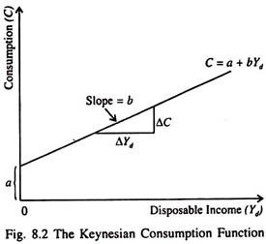
Source: Diptimai, K. Simple Keynesian Model (SKM): Assumptions, Conditions and Defects

Conclusion
In accordance with Sojka (1999), the developed capitalist market economy is not capable to achieve a full use of economic sources and it is neither capable to create adequate condition for a full employment according to Keynes. It is also distinguished by a random and inequitable division of wealth and allocation of income. Keynes had also a very negative opinion towards rentiers.
He discusses the problem of ineffective demand from the point of view of full employment and full used other economic sources. In consideration of Kyness thoughts, the market economy is not itself capable of creating sufficient powers in order to restore fully used of economic sources. That is why this mechanism must be completed by the external stabilization at the basis of interventionism.
Keynes had proposed two options how to use all economic sources in a developed capitalistic market economy. The first option was about an allocation of income. He proposed to a government to raise inheritance taxes and a progressive imposition of a taxes. This measure would lead to a rise in the slope towards consumption and downslope towards savings and it would all aim to an easier equalization of the slope towards investments and slope towards savings. The second option was about the influence of slope towards investments through monetary and investments politics which would be concentrated on long-term maintenance of low interest rate.
In the Keynes approach, the role of the state is very important. The state must pay attention to the market economy and mostly if the market economy used fully all economy sources, which are available especially labour sources. This is the only intervention of the state to the market economy as he was radically against of the central allocation of sources.
To conclude Keynes entered into our history. He tried to overthrow the economic theory that was in its time generally recognized and desired and replace it with a new one and he partly succeeded. From the 1970s onwards, there were Keynes thoughts and his followers have been subject to great criticism, and gradualy almost all have been denied.

Consumption function
"Perhaps we thought that more we have, less we need. When more things going from the set I need to have to the set I have, the set I need to have should get smaller. We thought consumption would lead to saturation of our needs. The opposite proved to be true. More we have, more we need." (Sedláček, 2009)
Consumption is a major concept in economics and is also studied in many other social sciences. Economists are particularly interested in the relationship between consumption and income, as modeled with the consumption function. The consumption function is a mathematical function that expresses consumer spending at a macroeconomic level in terms of its determinants, such as income and accumulated wealth. When one studies consumption, one also studies saving, which is the part of the income that is not consumed. This paper will explain more in detail the basic of these two functions. Every step will be completed by graphs and equations for better understanding.
This chapter explains the definition of the term consumption and describes different factors which influence consumption. Its third part clarifies mathematical relationship in consumption function by explanation of relevant equations.

Consumption function
Consumption function, in economics, is the relationship between consumer spending and the various factors determining it. Consumption function might have various definitions depending on different schools of economists or on different economic models.

Definitions
The characteristics of consumption functions are important for many questions in both macroeconomics and microeconomics.
In macroeconomic, the model of the consumption function tracks total aggregate consumption expenditures; for simplicity it is assumed to depend on a basic subset of the factors economists believe are important at the household level. Analysis of consumption expenditure is important for understanding short-term (business cycle) fluctuations and for examining long-run issues such as the level of interest rates and the size of the capital stock (the amount of buildings, machinery, and other reproducible assets useful in producing goods and services). In principle, the consumption function provides answers to both short run and long run questions.
In the long run, since income that is not consumed is saved, the responsiveness of households to any tax policy (such as those meant to spur aggregate saving and increase the capital stock) will depend on the structure of the consumption function and particularly what it says about how saving responds to interest rates.
In the short run, the effectiveness of tax cuts or other income-boosting policies (such as those meant to stimulate a recessionary economy) will depend on what the consumption function says about how much the typical recipient spends or saves out of the extra income.
At the microeconomic level the structure of the consumption function is of interest in itself, but it also has a powerful influence on many other kinds of economic behaviour. For example, individuals with only a small stock of savings who are laid off from their jobs may be forced to take new jobs quickly, even if those jobs are a poor match for their skills. On the other hand, laid-off consumers with substantial savings may be able to wait until they can find a better job match. Whether a consumer is likely to have much savings when laid off will depend on the degree of patience reflected in the consumption function.

There exist four aggregate sectors of the macroeconomy: household, business, government, and foreign. These four key macroeconomic functions are responsible for four expenditures on gross domestic product. These four sectors are the primary "actors" on the macroeconomic stage. Macroeconomic theories then explain macroeconomic phenomena by exploring the interaction among these four sectors.

In macroeconomics, there exist two and three-sector economy. The two-sector economy represent households and business sector (business firms). The three-sector economy represent households, business firms and government.

In this paper, we will explain the conception of consumption function in two-sector economy.
In the real functioning economy, the most important component of the total aggregate expenditures is the total or final consumption of households. It seems to us as the best to begin with description of the process of determining the income in two-sector economy by analysing the consumption and so the consumption function.

The determinants of consumption
At the household or family level, various factors influence consumption: income, wealth, expectations about the level and riskiness of future income or wealth, interest rates, age, education, family size, consumer’s preferences (e.g., patience, or the willingness to delay gratification), consumer’s attitude toward risk, and by whether the consumer wishes to leave a bequest.

Income
The most important determinant is income. It is divided between disposable income and permanent income.
Permanent income corresponds to the income household has when temporary or transient influences are removed. Thus, it represents expected income in future years. According to the permanent income theory, developed by Friedman, consumers respond primarily to permanent income.
Disposable income (DI) corresponds to the amount of income a household has after receipt of transfer payments and payment of taxes. Disposable income is divided between consumption (C) and saving (S). Part of the income that is not consume is saved. Thus, DI = C+S

Other determinants
Wealth, change in household debt are others factors that influence household’s consumption and whose effect will be studied in the following section.

Consumption function

Consumption formula
In two-sector economy, it is clear that the consumption function in this case expresses a positive functional dependence between the final consumption expenditures of households and the total amount of their income (Y).
C = f (Y)

Two types of consumption can be noticed: autonomous consumption and induced consumption.
- autonomous consumption (CA) corresponds to the part of consumption expenditure in a given year which is not affected by changes in current disposable income. For example, refunding a loan is part of autonomous consumption. It is represented when income is equal to zero
- induced consumption (CI) is the portion of annual consumer purchases in a year that responds to change in disposable income. It is the one that is studied here.
- The total amount of the expenditures of households’ consumption is determined as a sum of autonomous consumption and induced consumption.
C = C_{A} + C₁

Marginal propensity to consume (mpc)
Marginal propensity to consume (MPC) corresponds to the amount households are willing to consume when they receive an extra czech crown of income.
$$mpc=\frac{ΔC_{1}}{ΔY}$$

As we can see from above, the total value of household expenditures for the final induced consumption is the sum of the disposable income and the marginal propensity to consume.
If we take this equation to the equation of total amount of expenditures of households’ consumption, we get the final form of the equation representing the consumption function in two-sector economy.
C = C_{A} + mpc * Y

Saving function
In the two-sector economy, households use their income to buy goods and services on the market, where the expenditures don’t have to reflect the value of their income. If households on a given market spend an amount that is generally lower than the amount of their income, they will save part of the income. Thus, it is clear that household savings (SH) can be defined as that part of the total household income that these businesses will not use to buy goods and services. If we look at this definition, we value household savings as the difference between their income and final consumption expenditure.
S_{H} = Y - C

In this equation, we can substitute the equation of consumption function for C, and we get

S_{H} = Y - ( C_{A} + mpc * Y) and so:

S_{H} = - C_{A} + (1 - mpc) * Y

From this equation, we can understand that the autonomous saving could be defined as the saving of households which their amount doesn’t depend on their value of disposable income. We know, that in two-sector economy, the households divide their income only between consumption expenditures and savings. The marginal propensity to save (mps) is so defined as:
mps = Δ S_{H} / Δ Y

We can then count the final saving function by the following equation:
S_{H} = mps * Y
It is now clear, that the saving function expresses the positive functional relation between total household savings and the amount of their income.
S_{H} = f (Y)

Consumption curves – graphs
The following chapter shows us consumption function curves and its possible shifts. The chapter is well completed by remarks for better understanding of the details of the graphs.

2.1 Consumption function curve: explanation

Graphical representation of the consumption function
savings

disposable income
consumption expenditure

disposable income

consumption

break-even point
saving

Graphical representation of the consumption function

The equation leading to the graphical representation of the consumption function is the following:
C = CA + CI*DI

Remarks
- How can it be possible to consume when the disposable income is zero?
Two explanations can be found. On one side, people can use credit, borrow money or their saving. On the other side, individual needs to consume: even when their income is zero, they need to eat for instance.
- What is the break-even point?
The break-even point is the point when consumption expenditures are equal to the disposable income

- What is the grey line?
Every point on the grey line, which is the disposable income, corresponds to point where disposable income is fully consumed, in other words when disposable income is equal to consumption expenditures

Shift of the curve

Change in wealth
Graphical representation of a positive shift of the consumption curve
disposable income
consumption expenditure
disposable income

consumption before increase in wealth

consumption after increase in wealth

Change in household debt
Graphical representation of a negative shift of the consumption curve
disposable income
consumption expenditure
disposable income

consumption before decrease in debt

consumption after decrease in debt

Thanks to this graph, we can see that the aggregate consumption expenditures increase when the total debt decreases. Indeed, households spend less money to refund loans and to pay interest rates and have thus a higher disposable income.

Summary
To conclude, consumption is a key concept in macroeconomic. Consumption function is the tool to understand how consumption expenditures is determined by various factors, the main one being disposable income. Saving being the part of income that is not consumed, studying consumption gives an insight of saving.

The AD-AS model
Before understanding the AD-AS model, it is important to remember the usefulness of supply and demand graphs. For the demand graph, the more something costs, the less people are willing to buy, while the less something costs, the more people are willing to buy. And for the supply graph, the opposite is true - as prices rise, suppliers seek to sell more, while falling prices mean less of a good will be supplied.

This is helpful for analysing one good at a time, but macroeconomists need to be able to examine the behavior of a whole economy at once. To accomplish this, economists calculate the aggregate demand and aggregate supply of an economy. Aggregate demand is the total amount of demand that an economy has, while aggregate supply is the total amount of supply an economy is capable of producing.

Aggregate demand
Aggregate demand (AD) refers to the amount of total spending on domestic goods and services in an economy. It includes all four components of demand:

- Consumption (C)
- Investment (I)
- Government spending (G)
- Net exports (exports minus imports: X – M)

This demand is determined by a number of factors, but one of them is the price level. The aggregate demand (AD) curve shows the total spending on domestic goods and services at each price level.

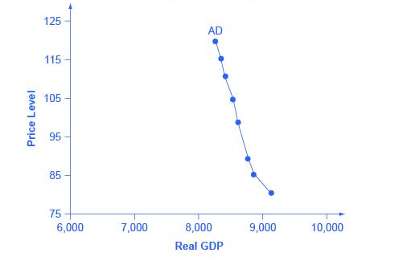
Figure 1: The aggregate demand curve
Source: "Building a Model of Aggregate Demand and Aggregate Supply" by OpenStaxCollege

This graph presents an aggregate demand (AD) curve. The horizontal axis shows real GDP and the vertical axis shows the price level. The AD curve slopes down, which means that increases in the price level of outputs lead to a lower quantity of total spending. The reasons behind this shape are related to how changes in the price level affect the different components of aggregate demand.

To fully understand why price level increases lead to lower spending, we need to understand how changes in the price level affect the different components of aggregate demand. Remember, the following components make up aggregate demand: consumption spending, C; investment spending, I; government spending, G; and spending on exports, X, minus imports M.

Aggregate demand = C + I + G + X - M

There are three theories why the aggregate demand curve slopes down:

1. The wealth effect
The wealth effect holds that as the price level increases, the buying power of savings that people have stored up in bank accounts and other assets will diminish, eaten away to some extent by inflation. Because a rise in the price level reduces people’s wealth, consumption spending will fall as the price level rises.

2. The interest rate effect
The interest rate effect is that as prices for outputs rise, the same purchases will take more money or credit to accomplish. This additional demand for money and credit will push interest rates higher. In turn, higher interest rates will reduce borrowing by businesses for investment purposes and reduce borrowing by households for homes and cars – thus reducing consumption and investment spending.

3. The foreign price effect
The foreign price effect points out that if prices rise in the United States while remaining fixed in other countries, then goods in the United States will be relatively more expensive compared to goods in the rest of the world. U.S. exports will be relatively more expensive, and the quantity of exports sold will fall. U.S. imports from abroad will be relatively cheaper, so the quantity of imports will rise. Thus, a higher domestic price level, relative to price levels in other countries, will reduce net export expenditures.

Therefore, the steep slope indicates that a higher price level for final outputs does reduce aggregate demand for all three of these reasons, but the change in the quantity of aggregate demand as a result of changes in price level is not very large.

Shifts in aggregate demand

When consumers feel more confident about the future of the economy, they tend to consume more. If business confidence is high, then firms tend to spend more on investment, believing that the future payoff from that investment will be substantial. On the other hand, if consumer or business confidence drops, then consumption and investment spending decline.

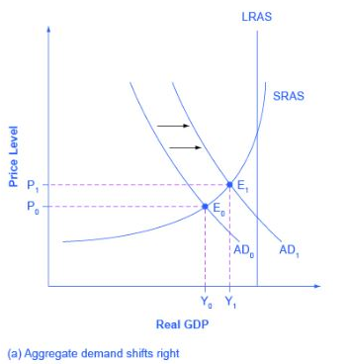
Figure 2: Shift in aggregate demand
Source: "Shifts in Aggregate Demand" by OpenStaxCollege

Because a rise in confidence is associated with higher consumption and investment demand, it leads to an rightward shift in the AD curve. This graph represents that this shift right moves the equilibrium from E0 to E1 – a higher quantity of output and a higher price level.

Aggregate supply
Aggregate supply, also known as total output, is the total supply of goods and services produced within an economy at a given overall price level in a given time period. It is represented by the aggregate supply curve, which describes the relationship between price levels and the quantity of output that firms are willing to provide. Normally, there is a positive relationship between aggregate supply and the price level.

Causes of Aggregate Supply Shifts
A shift in aggregate supply can be attributed to a number of variables. These include changes in the size and quality of labor, technological innovations, increase in wages, increase in production costs, changes in producer taxes and subsidies, and changes in inflation. Some of these factors lead to positive changes in aggregate supply, while others cause aggregate supply to decline.

For example, increased labor efficiency, perhaps through outsourcing or automation, raises supply output by decreasing the labor cost per unit of supply. By contrast, wage increases - prevalent in many areas of the U.S. as of 2016 - place downward pressure on aggregate supply by increasing production costs.

The Aggregate Supply Curve and Potential GDP
Firms make decisions about what quantity to supply based on the profits they expect to earn. Profits, in turn, are also determined by the price of the outputs the firm sells and by the price of the inputs, like labor or raw materials, the firm needs to buy. Aggregate supply (AS) refers to the total quantity of output (i.e. real GDP) firms will produce and sell. The aggregate supply (AS) curve shows the total quantity of output (i.e. real GDP) that firms will produce and sell at each price level.

Following figure shows an aggregate supply curve. Aggregate supply (AS) slopes up, because as the price level for outputs rises, with the price of inputs remaining fixed, firms have an incentive to produce more and to earn higher profits. The potential GDP line shows the maximum that the economy can produce with full employment of workers and physical capital.

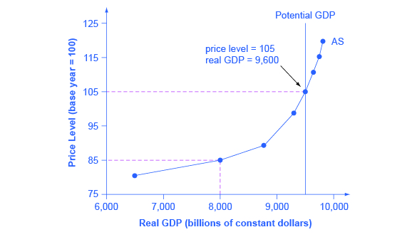
Figure 3: The Aggregate Supply Curve
Source: „The aggregate supply curve“ by OpenStaxCollege

Short run aggregate supply (SRAS)
Essentially, the short run of AS (SRAS) assumes that the level of capital is fixed. (i.e. in the short run you can’t build a new factory). However, in the short run you can increase the utilisation of existing factors of production, e.g. workers doing overtime. In the short run, an increase in the price of goods encourages firms to take on more workers, pay slightly higher wages and produce more. Thus the SRAS suggests an increase in prices leads to a temporary increase in output as firms employ more workers. The short run aggregate supply is affected by costs of production. If there is an increase in raw material prices (e.g. higher oil prices), the SRAS will shift to the left. If there is an increase in wages, the SRAS will also shift to the left.
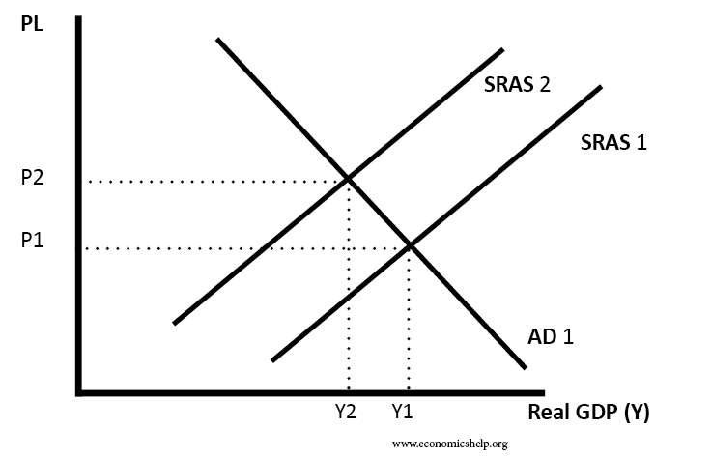
Figure 4: Shift of SRAS
Source: „Shift of SRAS“ by Economics Help
Long run aggregate supply (LRAS)
The long run aggregate supply curve (LRAS) is determined by all factors of production – size of the workforce, size of capital stock, levels of education and labour productivity. If there was an increase in investment or growth in the size of the labour force this would shift the LRAS curve to the right.
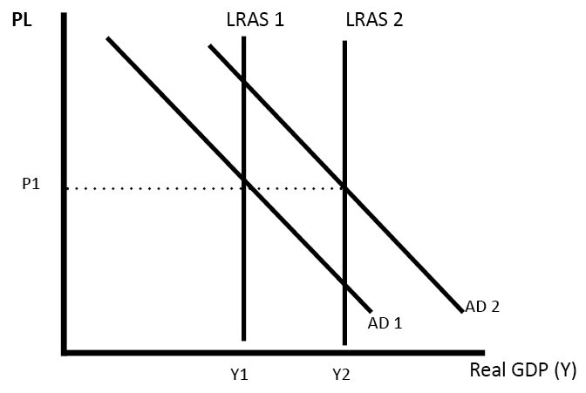
Figure 5: Shift of LRAS
Source: „Shift of LRAS“ by Economics Help
This is the classical view of long run aggregate supply (LRAS). It states that aggregate supply is not determined by the price level or AD, but is determined by factors of production, – land, labour, capital and labour productivity.

Interpreting the AD/AS model
The intersection of the aggregate supply and aggregate demand curves shows the equilibrium level of real GDP and the equilibrium price level in the economy. At a relatively low price level for output, firms have little incentive to produce, although consumers would be willing to purchase a high quantity. As the price level for outputs rises, aggregate supply rises and aggregate demand falls until the equilibrium point is reached.

Figure 6 combines the AS curve from Figure 3 and the AD curve from Figure 1 and places them both on a single diagram. In this example, the equilibrium point occurs at point E, at a price level of 90 and an output level of 8,800.

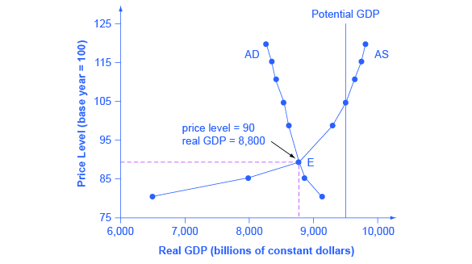
Figure 6: Aggregate Supply and Aggregate Demand
Source: „Aggregate supply and aggregate demand“ by OpenStaxCollege

Unlike the aggregate demand curve, the aggregate supply curve does not usually shift independently. This is because the equation for the aggregate supply curve contains no terms that are indirectly related to either the price level or output. Instead, the equation for aggregate supply contains only terms derived from the AS-AD model. For this reason, to understand how the aggregate supply curve shifts, we must work from the AS-AD model as a whole. The intersection of the short-run aggregate supply curve, the long-run aggregate supply curve, and the aggregate demand curve gives the equilibrium price level and the equilibrium level of output.

Summary
The AD/AS model is one of the fundamental tools in economics because it provides an overall framework for bringing economic factors together in one diagram.
The upward-sloping short run aggregate supply (SRAS) curve shows the positive relationship between the price level and the level of real GDP in the short run. Aggregate supply slopes up because when the price level for outputs increases, while the price level of inputs remains fixed, the opportunity for additional profits encourages more production. The aggregate supply curve is near-horizontal on the left and near-vertical on the right. In the long run, aggregate supply is shown by a vertical line at the level of potential output, which is the maximum level of output the economy can produce with its existing levels of workers, physical capital, technology, and economic institutions.

The downward-sloping aggregate demand (AD) curve shows the relationship between the price level for outputs and the quantity of total spending in the economy. It slopes down because of: (a) the wealth effect, which means that a higher price level leads to lower real wealth, which reduces the level of consumption; (b) the interest rate effect, which holds that a higher price level will mean a greater demand for money, which will tend to drive up interest rates and reduce investment spending; and (c) the foreign price effect, which holds that a rise in the price level will make domestic goods relatively more expensive, discouraging exports and encouraging imports.

Money market
The money market represents together with the capital market or commodity market the most important part of the financial market. Financial market is the system of relations and tools, which are collecting, deploying and dividing or allocating free money devices, by influence of the demand and supply. The financial market is the indispensable component of the market economy and the development on the financial market is capturing almost precisely the development of the market economy. That’s why it’s important to understand the money market to unify the knowledge of the economy itself.

Money market – definition and function

Money market is the part of the financial market, where the short-term instruments are being trade. These instruments are having the maturity to only one year, they are with relatively low risk and so with relatively low profit. The characteristic of the money market is also a high liquidity of separate instruments.
It is also defined as the tool for financing the financial system. We can imagine the money market as well as a group of institutions, which are lending money to each other; or as a net of the banks, brokers, buyers, sellers and various mediators, where the national bank of the country is the middle of the net, lending the money to other banks for lower interest than people are taking loans from their banks. The national bank decides the optimal height of the interest for which it is lending the money to the banks, and so is influencing the economy of the state.
Function
The money market has several functions, firstly to help the national bank to use the money market as a tool for influencing the national economy. The functions are following:
- It allows the redistribution of the temporarily free short-term capital.
- It allows the National bank to flexibly regulate the amount of the money in the economics
- It determines the price of the short-term capital.
- It determines the price of the short-term interest rate.
- It represents the effective tool of the regulation of the national activity
- It allows to issuers of money securities to gain satisfactory amount of the capital

Participants on the money market

On the money market, there are financial institutions or dealers in money or credit which want to either borrow or lend. In contrast to capital market, which is working with long-term funding, the money market works with the short-term instruments, commonly named “papers”. There are few major participants on the money market:
- Central bank
- Commercial banks
- Merchant banks
- Trading companies
- Retail and institutional money market funds
- Cash management programs

Money market instruments

Short-term loans

The first of the money market instruments are the short-term loans. These loans are usually taken from 7days up to 12 months. They are provided by banks for covering the current assets of the company. Short-term loans can be in the form of:
Monetary loans
Monetary loans represent the loan of actual money, when the client has to pay off the amount with the interest included.
Short-term bank loans
Short-term bank loans are the easiest forms of the bank loans. The loan can be gained or payed off at once or gradually. It is granted for a concrete need, for example the favourable purchase, threat in the salary payment etc. When its concerning new clients, bank is usually asking the interest rate, but for solid existing clients, bank might not ask any interest.
Revolving credit
Revolving credit is a kind of a modification of the short-term bank loan. Client is paying back the credit gradually, when he can also take the money from the credit back, to the amount of the approved credit scope.
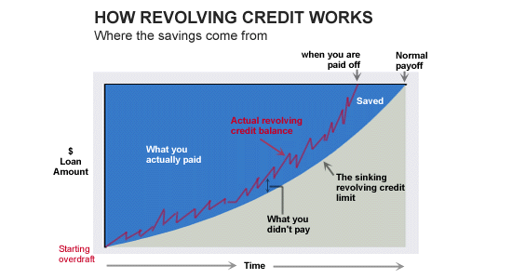
Figure 1 The functionning of the revolving credit, interest.co.nz

Lombard credit
Lombard credit represents loan of the financial funds from bank for the short time period against the liquid, moveable deposit. These moveable deposits can be the securities, exchange bills, invoices but also goods and precious items. The most common type of the Lombard credit is the deposit of securities. It is mostly favourable for the bank, because if the client is not capable to pay off the credit, the securities are because of its high liquidity very quickly marketable. But this credit is also favourable for the client, who is not obliged to sell the papers when he’s not in need.
Ovedraft account
The overdraft account is the most important loan in the market economy. It is granted on the current account, when the client can overdraw the account for the given limit. That means that on the current account, the client can have the credit balance or be “in the red numbers” – in the debit balance, when the debit balance is having higher interest rates than the normal bank loan. The overdraft account serves to clients to cross over temporary shortage of financial funds.
Loan commitments
Obligations are situation, when the bank is not giving to the client the actual money, but is guaranteeing the client for the profit of the third person. It is conferring its own name. On that account the bank is not asking for the interest, but for the provision.
Aval credit
Is also called as a guarantor’s credit. The bank by providing the aval credit is promising the guarantee of its client towards third person. It can be the payment commitment, but also commitment of some service or delivery of goods. It is provided on the basis of the contract, where the maximal amount of money guaranteed by the bank, the conditions and the due date is given. The price for the company is the aval provision, which is counted by the bank from the guaranteeing amount.
Acceptance credit
Acceptance credit means granting the guarantee on the bill of exchange emitted by the postulating company, with the condition, that the company will arrange the funds before the maturity of the exchange bill. The bank is becoming by accepting the acceptance credit the main debtor, and so is obliged to pay the exchange bill, even though if the client didn’t arranged the funds to the bank. By granting the acceptance credit is bank asking the acceptance provision, counted again from the percentage of the final amount guaranteed.

Short-term government securities

Bill of exchange
“A bill of exchange is a written order used primarily in international trade that binds one party to pay a fixed sum of money to another party on demand or at a predetermined date.“
It is an abstract security, so that means, that there is no reason for the drawing. From the abstraction of the Exchange bill we can see, that the debtor can not bind any special conditions, so the exchange bill is considered as the unconditional written debtor commitment.
Cheque
Cheque is the type of security, which gives to the bank the unconditional order to pay to the deliverer the given amount of money. Cheque is always mature on demand, when the period for the pay off of the cheque is in one state 8 days, in other state 20 days and in other continent 70 days.
Short-term government securities
- Short-term government obligations
- Short-term securities of local authorities of the government (cities and communities)
- Treasury bills, which are being issued by the government to cover the budget deficit. Treasury bills are considered as very security with high quality, zero risk (issuer is national bank) and high liquidity in period of 3-6 months.
Short-term commercial papers
- Bank obligations – representing the securities of the bank, also called the certificates of deposit.
- Contracts – specific securities, the basic aim is to arrange fixed term deals.
- Forwards – securities representing the promise to buy or sell certain amount of goods, currency or securities in the future for given price. Investment in forwards is protection in price fluctuation.
- Futures – almost same as forwards, but we can continue in trading.
- Options – as futures, but represent only the promise, not the obligation to buy or sell given goods.

The exchange rate

Nominal exchange rate and foreign exchange market

The nominal exchange rate is the exchange ratio between two national currencies. It is the price for the unit of a currency, expressed in units of another currency. As an exchange ratio of two currencies the exchange rate in two different versions can be expressed. Take, for example, the exchange rate between the euro and the US dollar: on the one hand, you can specify how many euros are paid for one dollar, i.e. $ 1 = € 0.83. Then, from the point of view of i.e. the Federal Republic of Germany, the price of the foreign currency is expressed in domestic currency. This course is also called as price exchange rate, as price quotation or also as foreign exchange course. In this case the fixed value of the price quotation is abroad. If we denote this exchange rate with w$, the price quotation would be: w$ = 0,83 €/$. Internationally, quantity quotation is the most widespread.
Secondly, the exchange rate can also be expressed by indicating the amount of foreign currency to be paid for a domestic currency unit, i.e. 1 € = 1.20 $. In this case it is called quantity exchange rate or quantity quotation: w€ = 1,20 $/€. The fixed value currency is in the inland.
It can be seen that the price exchange rate and the exchange rate seem to be in inverse proportion to each other, that means, the price exchange rate corresponds to the reciprocal value of the exchange rate. If we use the term "exchange rate" below, then the price quotation is always meant.
Like any other price, the exchange rate also forms as the price of a foreign currency unit in a market, namely the foreign exchange market. The nominal exchange rate can thus be considered as an exchange and valuation instrument for trade in goods and services between different countries. That is, the nominal exchange rate informs us of the amount of domestic currency we need to purchase a certain amount of goods or services in foreign currency. This also means: The exchange rate gives us the price of foreign goods in domestic currency.
Interesting are changes in the exchange rate. It is said that one currency "rewards" or "depreciates" relative to another. If one speaks of an appreciation of the domestic currency, then this becomes "more expensive" compared to the foreign currency. In a devaluation, the domestic currency in relation to the foreign currency "cheaper". This can be clarified on the basis of the price and quantity quotation already presented. An appreciation of the domestic currency is called when, according to the quotation, the price of the foreign currency - measured in units of domestic currency - decreases (that is, if, according to the price quotation, the price of the domestic currency rises). In the case of a devaluation of the domestic currency, the price of the domestic currency decreases in quantity quotation or the price of the foreign currency, measured in units of domestic currency, increases according to the price quotation.

Effective nominal exchange rate

The effective nominal exchange rate is used to compare international price competitiveness (that is, the competitiveness of prices and costs of goods produced in one economy) with more than one other country. Price competitiveness relates the competitiveness of a world market economy to the exchange rate, with the question of how the competitiveness of domestic products on the world market changes when the exchange rate changes relative to the trading partners' currencies.
The effective nominal exchange rate is determined using a weighted basket of currencies. This can be summarized as follows: The currencies of the major trading partners of the domestic market are summarized, with the currencies of these countries being weighted with the respective percentage share of their foreign trade with the domestic trade volume. The European Central Bank calculates the effective nominal exchange rate for the euro as a weighted product of nominal exchange rate indices based on volume quotation. As a result, the term can no longer be interpreted as an exchange rate in the original sense, but it can make a statement about the development over time (appreciation / depreciation), i.e. the gain or loss of relative price competitiveness.
This is of interest to many economies, as the development of exports and imports are determined to a significant degree by their prices. When the exchange rate of a country effectively appreciates, that country loses its price competitiveness vis-à-vis its major trading partners. The loss of price competitiveness and the associated decline in exports affect economic growth, employment and the current account.

Real exchange rate

However, not only the nominal exchange rate is of interest to foreign trade, but also the relative price level influences the decisions of the actors. This can be illustrated by a simple example. For this example, let's consider the real exchange rate in quantity quotation.
A large chain of German consumer electronics stores regularly imports consumer electronics from Japan. For the importer, it is crucial how many, say, DVD players, at what price can be imported. This depends on the nominal exchange rate, the price level for DVD players in Japan (ie the price in yen, which is required in Japan for a DVD player) and the price level of DVD players in Germany.
If e is the nominal exchange rate, pª the price level abroad and p the domestic price level, then the real exchange rate in volume quotation is:
e^{r} = e*p/ pª
By increasing the real exchange rate, Japanese exporters in Germany are gaining competitiveness, because then the price which is paid by German importers for their goods and services (here: for the DVD player) increases. In our example, the real exchange rate rises when the euro appreciates against the yen, the price level for DVD players in Japan falls, or the price level for DVD players in Germany increases. All in all, the Japanese DVD players are cheaper for the German importer.
If the real exchange rate between the euro and the yen rises (sinks), one can say that Japanese exporters are gaining (losing) competitiveness. Since the real exchange rate includes the price level, it represents the "real" price of goods and services in domestic currency. The following table illustrates how the real exchange rate changes in volume quotations when one of the variables mentioned (er, pa and p) and what consequences this has for the competitiveness of German exports abroad. All operations are subject to the Ceteris Paribus clause.

Real exchange rate in volume quotation
Euro increases in nominal terms | e ↑ | e^{r}↑ | Euro appreciates/enhances „real“  competitiveness decreases
Euro decreases in nominal terms | e ↓ | e^{r}↓ | Euro devalues „real“  competitiveness increases
Foreign price level decreases | pª↓ | e^{r}↑ | Euro appreciates/enhances „real“  competitiveness decreases
Foreign price level increases | pª↑ | e^{r}↓ | Euro devalues „real“  competitiveness decreases
Domestic price level decreases | p ↓ | e^{r}↓ | Euro devalues „real“  competitiveness decreases
Domestic price level increases | p ↑ | e^{r}↑ | Euro appreciates/enhances „real“  competitiveness increases

The real exchange rate can also be seen in price quotation as
e^{r} = e*pª / p

The effect of a change in the nominal exchange rate e, the domestic price level p and the foreign price level pª on the real exchange rate and the competitiveness of the German export industry can be seen from the following table (using the ceteris paribus clause)

Real exchange rate in price quotation
Euro increases in nominal terms | e ↓ | e^{r}↓ | Euro appreciates/enhances „real“  competitiveness decreases
Euro decreases in nominal terms | e ↑ | e^{r}↑ | Euro devalues „real“  competitiveness increases
Foreign price level decreases | pª ↓ | e^{r}↓ | Euro appreciates/enhances „real“  competitiveness decreases
Foreign price level increases | pª ↑ | e^{r}↑ | Euro devalues „real“  competitiveness decreases
Domestic price level decreases | p ↓ | e^{r}↑ | Euro devalues „real“  competitiveness decreases
Domestic price level increases | p ↑ | e^{r}↓ | Euro appreciates/enhances „real“  competitiveness increases

Effective real exchange rate
Just like the effective nominal exchange rate, the effective real exchange rate also serves to analyze international price competitiveness. As with the effective nominal exchange rate, the effective real exchange rate also results from a weighted basket of currencies. Here again the trading volume serves as a weighting factor. The calculation is made, at least for the euro area, just like the effective nominal exchange rate. In contrast, however, the domestic price level and that of the respective partner country are included in each case. The real effective exchange rate gives the best information about the international price competitiveness of an economy.

Summary

Money market represents one of the most important part of the financial market, and so for the market economy. We have found out the major functions of the money market, as well as the main participanst of it. Indivisible part of the money markets are for sure their instruments, which we have divided into two parts – the short-term loans and short-term government securities.

Aggregate supply
Aggregate supply, also known as total output, is the total supply of goods and services produced within an economy at a given overall price level in a given time period. It is represented by the aggregate supply curve, which describes the relationship between price levels and the quantity of output that firms are willing to provide. Normally, there is a positive relationship between aggregate supply and the price level.

Causes of Aggregate Supply Shifts
A shift in aggregate supply can be attributed to a number of variables. These include changes in the size and quality of labor, technological innovations, increase in wages, increase in production costs, changes in producer taxes and subsidies, and changes in inflation. Some of these factors lead to positive changes in aggregate supply, while others cause aggregate supply to decline.

For example, increased labor efficiency, perhaps through outsourcing or automation, raises supply output by decreasing the labor cost per unit of supply. By contrast, wage increases - prevalent in many areas of the U.S. as of 2016 - place downward pressure on aggregate supply by increasing production costs.

The Aggregate Supply Curve and Potential GDP
Firms make decisions about what quantity to supply based on the profits they expect to earn. Profits, in turn, are also determined by the price of the outputs the firm sells and by the price of the inputs, like labor or raw materials, the firm needs to buy. Aggregate supply (AS) refers to the total quantity of output (i.e. real GDP) firms will produce and sell. The aggregate supply (AS) curve shows the total quantity of output (i.e. real GDP) that firms will produce and sell at each price level.

Following figure shows an aggregate supply curve. Aggregate supply (AS) slopes up, because as the price level for outputs rises, with the price of inputs remaining fixed, firms have an incentive to produce more and to earn higher profits. The potential GDP line shows the maximum that the economy can produce with full employment of workers and physical capital.

Figure 3: The Aggregate Supply Curve
Source: „The aggregate supply curve“ by OpenStaxCollege

Short run aggregate supply (SRAS)
Essentially, the short run of AS (SRAS) assumes that the level of capital is fixed. (i.e. in the short run you can’t build a new factory). However, in the short run you can increase the utilisation of existing factors of production, e.g. workers doing overtime. In the short run, an increase in the price of goods encourages firms to take on more workers, pay slightly higher wages and produce more. Thus the SRAS suggests an increase in prices leads to a temporary increase in output as firms employ more workers. The short run aggregate supply is affected by costs of production. If there is an increase in raw material prices (e.g. higher oil prices), the SRAS will shift to the left. If there is an increase in wages, the SRAS will also shift to the left.
Figure 4: Shift of SRAS
Source: „Shift of SRAS“ by Economics Help

Long run aggregate supply (LRAS)
The long run aggregate supply curve (LRAS) is determined by all factors of production – size of the workforce, size of capital stock, levels of education and labour productivity. If there was an increase in investment or growth in the size of the labour force this would shift the LRAS curve to the right.
Figure 5: Shift of LRAS
Source: „Shift of LRAS“ by Economics Help
This is the classical view of long run aggregate supply (LRAS). It states that aggregate supply is not determined by the price level or AD, but is determined by factors of production, – land, labour, capital and labour productivity.
Interpreting the AD/AS model
The intersection of the aggregate supply and aggregate demand curves shows the equilibrium level of real GDP and the equilibrium price level in the economy. At a relatively low price level for output, firms have little incentive to produce, although consumers would be willing to purchase a high quantity. As the price level for outputs rises, aggregate supply rises and aggregate demand falls until the equilibrium point is reached.

Figure 6 combines the AS curve from Figure 3 and the AD curve from Figure 1 and places them both on a single diagram. In this example, the equilibrium point occurs at point E, at a price level of 90 and an output level of 8,800.

Figure 6: Aggregate Supply and Aggregate Demand
Source: „Aggregate supply and aggregate demand“ by OpenStaxCollege

Unlike the aggregate demand curve, the aggregate supply curve does not usually shift independently. This is because the equation for the aggregate supply curve contains no terms that are indirectly related to either the price level or output. Instead, the equation for aggregate supply contains only terms derived from the AS-AD model. For this reason, to understand how the aggregate supply curve shifts, we must work from the AS-AD model as a whole. The intersection of the short-run aggregate supply curve, the long-run aggregate supply curve, and the aggregate demand curve gives the equilibrium price level and the equilibrium level of output.

Summary
The AD/AS model is one of the fundamental tools in economics because it provides an overall framework for bringing economic factors together in one diagram.
The upward-sloping short run aggregate supply (SRAS) curve shows the positive relationship between the price level and the level of real GDP in the short run. Aggregate supply slopes up because when the price level for outputs increases, while the price level of inputs remains fixed, the opportunity for additional profits encourages more production. The aggregate supply curve is near-horizontal on the left and near-vertical on the right. In the long run, aggregate supply is shown by a vertical line at the level of potential output, which is the maximum level of output the economy can produce with its existing levels of workers, physical capital, technology, and economic institutions.

The downward-sloping aggregate demand (AD) curve shows the relationship between the price level for outputs and the quantity of total spending in the economy. It slopes down because of: (a) the wealth effect, which means that a higher price level leads to lower real wealth, which reduces the level of consumption; (b) the interest rate effect, which holds that a higher price level will mean a greater demand for money, which will tend to drive up interest rates and reduce investment spending; and (c) the foreign price effect, which holds that a rise in the price level will make domestic goods relatively more expensive, discouraging exports and encouraging imports.

Investments (Macroeconomics approach)
1) Definition of Investment

Investment in economics is not the same as the word investment we used daily.
investment in the daily English langage means „ a place to put your wealth“ (Lieberman, M. and Hall, R. (2005), p.110)
investment in economics means the acquisition of production goods (Numilog) or in other words, investment is “the addition to the community’s stock of tangible capital goods (capital goods being equipment, structures, or inventories). […] There is investment only when real capital is created” (Samuelson, P. and Nordhaus, W. (1989), p.136).
2) Tools to modify investment

Short-run economic activity and long-run economic growth depend greatly on investment (Samuelson, P. and Nordhaus, W. (1989), p.137), that is why governments can seek to encourage investment and they have different tools in order to reach that goal (Lieberman, M. and Hall, R. (2005), p208-2012).
Efforts towards business: The government can for example lower the taxes for companies investing in order to push them to invest, in other words: it makes investment more profitable - and this is the case for every interest rate-, as you can see on Figure 1 below which shows the loanable fund market (simplified). We can here see that the equilibrium between the supply of funds (or saving) and the demand for funds (investment) shifts to the right.
Original investment
Interest rate
Euros per year

Savings
New investment

Figure 1

Effort towards households: The government can also choose to increase investment by encouraging household to save more, for example by decreasing the capital gains tax (“a tax on profits earned when a financial asset is sold at more than its acquisition price”), so that stocks and bonds have more value and push households to save in order to buy it. Figure 2 shows again the loanable fund market and the saving curve shows us that investment is higher and with a lower interest rate which will push companies to invest.

Figure 2
Interest rate
Euros per year

Original savings
Investment

New savings

Lower the government’s budget deficit: If the government has less or no deficit, it will borrow less in the loanable fund market, the demand will then fall and the interest rate too. A lower interest rate will push businesses to invest. (In Figure 1 and 2, the budget deficit was not represented in order to simplify the loanable fund market).

3) Investment in GDP

In the GDP formula, economists actually talk about private investment but they referred to it as investment.
Reminders about GDP
“Gross domestic product or GDP measures the total value of all final goods and services produced in the economy during a given period. “ (Worldeconomics, GDP).
GDP= C+G+I+NX, where C is the consumption of consumers (goods and services), G is the government expenditure, I is the investment and NX is the net export (Corporate finance institute, GDP Formula).
Investment includes 3 components (Lieberman, M. and Hall, R. (2005), p.107):
business spending on plant, equipment, software
new homes construction
accumulation of unsold inventories (inventories are produced goods but that have not already been sold. Indeed GDP is measuring the goods and service that have been produced during the year)

4) Different types of investment

Net and gross investment
Net investment is „gross investment minus depreciation of capital goods“. (Samuelson, P. and Nordhaus, W. (1989), page 548). Net investment is also defined as „ the amount spent by a company or an economy on capital assets“(Investopedia, Net investment).

Domestic and foreign investment
Foreign investment „is when a company or individual from one nation invests in assets or ownership stakes of a company based in another nation“ (Study.com, foreign investment). Foreign investment is divided by direct and indirect investments:
Direct investments are the physical investments and acquisitions a company make in another country as their own, such as buildings, factories, ect.
Indirect investments are the positions or stakes purchased by company on a foreign stock exchange.
Domestic investment is the investment within the country where the company comes from.

Summary
- Investment in economics and in the common language are not the same at all and leads to missunderstanding.
- To modify investment the government can choose to focus on businnesses, households or on its own budget deficit.
- Investment is one of the four GDP component
- We talk also of net or gross investment and of direct and indirect investment

Inflation and fiscal policy

Inflation Introduction
Inflation and fiscal policy affect the level of economic activities of a country. Fiscal policy is the government’s expenditure policy that influence macroeconomic conditions.
Inflation
What is inflation?
Inflation generally means persistent increases in the majority of prices in an economy. The inflation between two points in time is defined as the percentage increase of the price index between these two points in time.
It implies an erosion of the real value (e.g. purchasing power) of a given currency with respect to the good and services bought by customers.
In practise, it means that if inflation is present in an economy, customers need to spend more and more money to buy the same amount of goods and services.
Inflation is measured as the increase in the costumer price index (CPI). An appreciable number of countries in the world prefer to sustain an inflation rate between 2 and 3 percent. In the Czech Republic, it is measured by the Czech Statistical Office and today’s inflation rate is 2,2 % (data from November 2018).
If the price index decreases between two points in time, we say that the inflation is negative or that we have deflation.

There are four types of inflation rate.

Inflation rate as an increase in average annual CPI indicates percentage change in last 12-month average over preceding 12-month average
It is taken into account particularly when e.g. real wages and pensions are calculated. Average year-on-year inflation rate in 2017 was 2,5 %.

Picture 1.1: Average year-on-year inflation rate in years
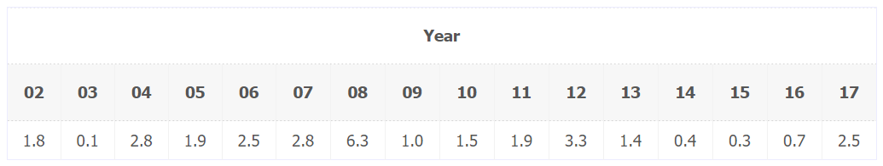
Source: Czech Statistical Office (2018)

Inflation rate as an increase in CPI compared with the corresponding month of preceding year indicates percentage change in price level between the reference month of a given year and the corresponding month of preceding year
It thus excludes seasonal variations. It is taken into account when e.g. real interest rates, real increase in property value, valorisation are calculated.

Picture 1.2: Inflation rate – between month of a given year and the corresponding month of preceding year
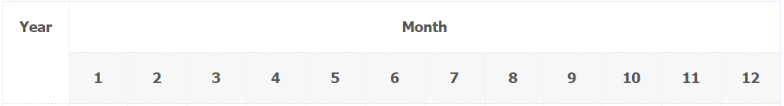
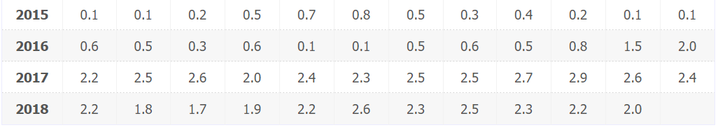
Source: Czech Statistical Office (2018)

Inflation rate as an increase in CPI compared with preceding month indicates percentage change in price level between the reference month and preceding month
Picture 1.3: Inflation rate – between the reference month and preceding month
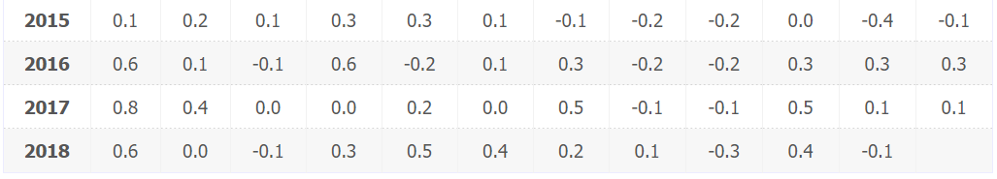
Source: Czech Statistical Office (2018)

Base indices – Inflation rate as an increase in the CPI compared with the base period (the average of 2015 = 100) indicates a change in the price level between the reference month of a relevant year against the average of 2015
All consumer price indices serving to measure the inflation rate for different time periods are calculated using base indices of consumer prices to a base period (with the average of 2015 = 100 as the base). In these calculations the following rule is applied: inflation rates are expressed as the overall consumer price index for households in total. The inflation rate is used for an analysis of detailed long-term trends (time series) in price levels and cost of living.

Picture 1.4: Base indices – Inflation rate
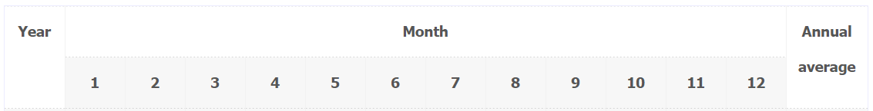
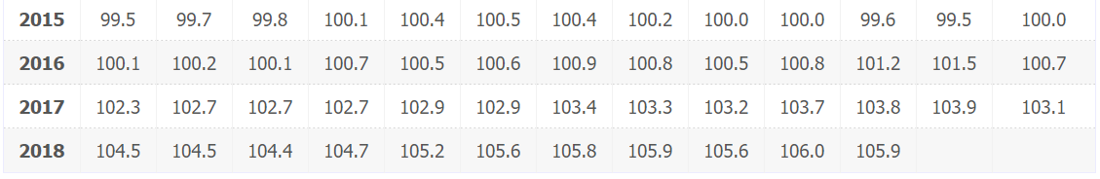
Source: Czech Statistical Office (2018)

Inflation rate calculation
Inflation rate calculation is following. If P_{t−1} represents the price level last year and P_{t} represents today’s price level, then the inflation rate over the past year can be written as:
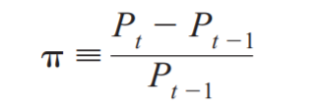
where π stands for the inflation rate. Correspondingly, today’s price level equals last year’s price level adjusted for inflation:

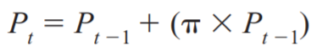

Inflation means increases of prices in an economy that affect the level of economic activities of a country. If the inflation is present in an economy, customers need to spend more and more money for the same amount of goods and services.
Inflation can be measured by the contumer price index. The preferable inflation rate is between 2 and 3 percent.
Negative inflation is called deflation.
There are four types of inflation rate, however, year-on-year inflation rate is the most common.
Inflation rate can be calculated with a formula.

Fiscal policy

Fiscal policy
What is fiscal policy?
Fiscal (budget) policy is a tool of economic policy in the hands of the government. Fiscal policy deals with the formation of both the revenue side (taxes, customs, social insurance) and the expenditure side of the budget. The budget is approved in the form of a law and must be approved by the Parliament. Fiscal policy is used in conjunction with the monetary policy implemented by the Czech National Bank.

Fiscal policy targets
Fiscal policy has its targets that are following:
- To maintain economic growth
- To maintain high employment
- To help preserve price stability (to keep inflation low)
- To make the business cycle in the expansion phase

Fiscal policy tools
To reach the fiscal policy targets, there are some tools that are used.
Tools of fiscal policy can be divided into two parts – receipts and expenditure (parts of budget) and automatic stabilizers.

- Receipts and expenditure
The two main tools of fiscal policy are the parts of the public budget: receipts and expenditure.
Picture 2.1: Budget
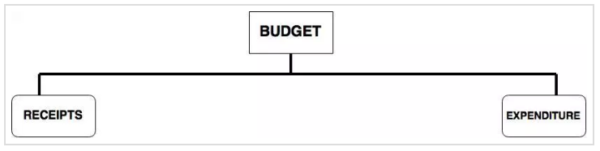
Source: Wordpress (2015)

The receipts include revenue receipts (tax and non-tax) and capital receipts as we can see in the following picture.

Picture 2.2: Receipts
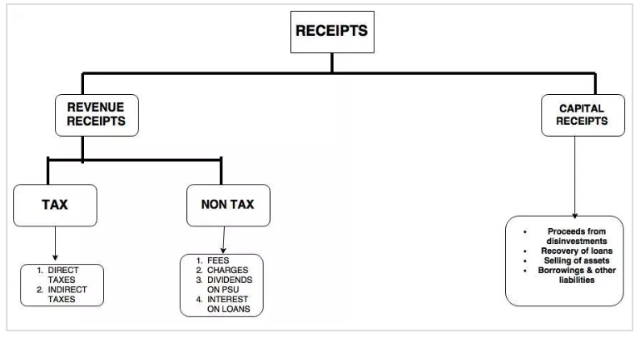
Source: Wordpress (2015)

The expenditure includes revenue expenditure (developmental and non-developmental expenditure) and capital expenditure as we can see in the following picture.

Picture 2.3: Expediture
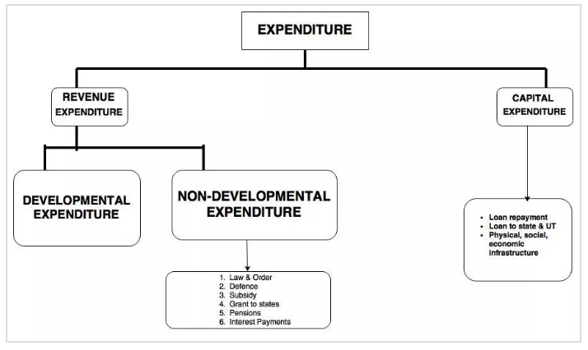
Source: Wordpress (2015)

The key is finding the right balance and making sure the economy does not lean too far either way.

- Automatic stabilizers
They work automatically in the economy and are helpful for ensuring the efficient use of production resources and as well as making the actual product as similar as possible to the potential one. Among the stabilizers we can include:

- The principle of progressive income tax
- The principle of unemployment insurance and social transfers
- The existence of subsidies to agriculture
- State purchase of agricultural surpluses

Types of fiscal policy
There are two types of fiscal policy.
- Expansionary
- Contractionary

Picture 2.1: Expansionary vs contractionary policy
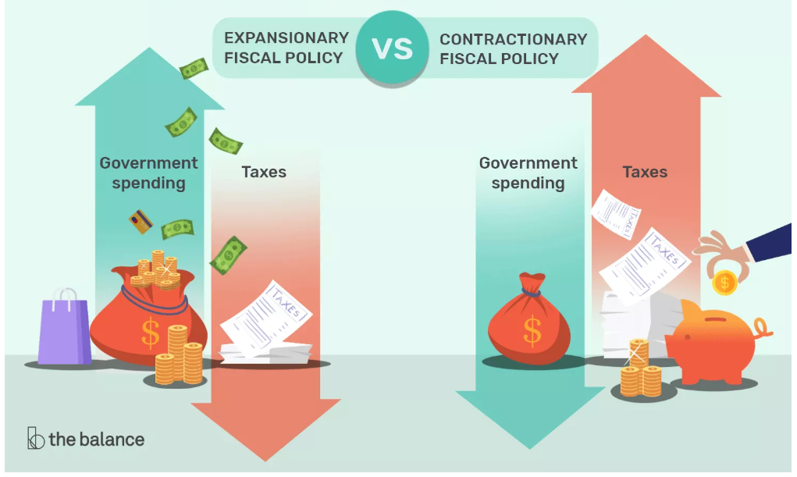
Source: The Balance (2018)

- Expansionary fiscal policy
It is the most widely-used. It stimulates economic growth.
The government either spends more, cuts taxes, or both. The idea is to put more money into consumers’ hands, so they spend more. Examples include public works projects, unemployment benefits, and food stamps. The money goes into the pockets of consumers, who go right out and buy the things businesses produce.
Short-term effect: The government either increases its purchases or reduces taxes, gross national product rises, and employment grows, however, the price level often rises too.

Long-term effect: It leads to higher prices and thus to inflation, it means, there is no change in product and employment levels, but the price level rises.

- Contractionary fiscal policy
It is rarely used. Its goal is to slow down economic growth when inflation is needed to be slowed down. The government spends less and increase taxes. The customers spend less. The long-term impact of inflation can damage the standard of living as much as a recession. The tools of contractionary fiscal policy are used in reverse. Taxes are increased, and spending is cut.

Short-term effect: It reduces the level of price level, product and employment.

Long-term effect: It has the effect on increasing private investment, reducing price levels, interest rates and, if private investment expenditure does not fully cover government spending on purchasing, there is no change in the level of real product and employment.

Fiscal policy is a part of economic policy of a country led by its goverments. The main subject of this policy is the budget, it thus deals with the revenue as well as the expenditure of the budget.
Fiscal policy has its targets and tools for reaching these targets.
There are two types of fiscal policy – expansionary, stimulating economic growth, and contractionary, slowing down economic growth. Both of them are useful for its reasons. However, expansionary fiscal policy is used in the most of the examples.

The new growth model theory

Short introduction

The new growth theory model comes from a Paul Romer’s article published in 1986 and called “Increasing Returns and Long Run Growth”. In this article, Paul Romer links growth to behavior, initiatives, and development of economic agents’ qualifications. Since then, this theory has become one of the most important economic sciences subjects.

In addition, the new growth theory questions the Solow-Swan model developed in 1956. This theory excludes production factors to explain progress, but does not give any explanation for this progress. This model would conduct to a stationary growth, which has never been proved (Croissance endogène, exogène, n. d.).

Structure of the chapter

The Solow-Swan model
What is the new growth model theory?
How the new growth theory values knowledge and innovation
Health and well-being
The role of the public sector
Indicators
Example of the new growth theory
Scheme illustrating the new growth theory’s process
Limits of the new growth theory
Why is this theory better than others?

The Solow-Swan model

Before getting straight to my topic, it would be important to define the Solow-Swan model which I mentioned in the introduction. The basis of this model considers a closed economy which produces one single good and uses labor and financial capital. Technological progress and saving rate are considered as exogenous, which means that no explanation is given for these two factors; they just seem to be innate. There is no State, but there are a fixed number of firms in the economy, each having the same technological capital. The cost of production is constant and costs of production factors (including wages) are balanced out to ensure the full use of all available inputs. This model focuses on four variables: the production flow, the capital supply, the number of workers, the knowledge and the efficiency at work. The economy combines capital, labour, and knowledge to produce. On a long-term, it will conduct to a balanced state for all economies (Hoque, n. d.).
What is the new growth model theory?

The new growth theory is an economic growth theory which foregrounds humans’ desires and unlimited wants, fostering increasing productivity and economic growth. The new growth theory argues that real GDP per capita will perpetually increase because of people's pursuit of profits. As competitiveness lowers the profit in one area, people have to constantly look for better ways to do things or invent new products in order to get a higher profit. This is one of the main ideas that constitute the theory (Kenton, 2018).

The new growth theory focuses on two important points. First, it views technological progress as a product of economic activity, contrary to previous theories. Second, new growth theory argues that unlike physical objects, knowledge and technology are characterized by increasing returns, and these increasing returns drive the process of growth. The essential point of the theory is that knowledge drives growth. As ideas can be infinitely shared and reused, we can accumulate them without limit (Cortright, 2001).
How the new growth theory values knowledge and innovation

One of the reasons for companies to invest in human capital is the internal nurturing of innovation. By creating opportunities and making resources available within organizations, each individual should be encouraged to develop new concepts and technology for the consumer market (Kenton, 2018).

Indeed, the development of knowledge is seen as a key driver of economic development. The main idea of new the growth theory is that, in order to develop, economies should move away from an exclusive reliance on physical resources to expand their knowledge base. They should also support the institutions that help develop and share knowledge.
Therefore, governments should invest in human capital, especially in the development of education and skills. It should also support private sector in research and development and encourage inward investment. This will bring new knowledge, forming a sustainable process (New Growth Theory, n. d.).

However, innovation and technologies do not occur simply by chance. It rather depends on the number of people looking for new innovations or technologies and how hard they are working for it. Indeed, people have control over their knowledge capital (i. e. what to study, how hard to study…, etc.). If the profit incentive is great enough, people will choose to grow human capital and seek hard new innovations (Kenton, 2018).

There are two types of innovations: horizontal and vertical ones. Horizontal innovation is the development of new varieties of goods through research, which boosts the economy. When a design is developed by a researcher, other researchers have the possibility to develop additional designs. Then they can take out a patent on these designs and sell these to the immediate goods sector. It is a source of increasing rate of return (Hoque, n. d.).

Vertical innovation is the improvement of existing products. This can lead to the creation of new products or technologies. This would increase productivity and would generate a more sustainable increase in output growth. This contribution of knowledge investment is a benefit for the whole economy. In addition, each idea makes the next new ideas possible. That is why the investment in human capital can ensure a sustainable and long-time perspective growth (Hoque, n. d.).
Health and well-being

Another side of the human capital is the well-being of the labor. Indeed, a wealthy and healthy labor force will work in better conditions and also, will be more efficient. In addition, employees with better education levels should get more money for their work, and the economy will benefit from their higher capacity and productivity. Along with this growth and revenues, everyone will be able to invest for him and the others (Cortright, 2001).
The role of the public sector
Another argument of new growth theorists is that, governments should finance infrastructures projects, such as roads, rails, sea, and air transport. These kinds of projects involve the creation of public goods, which would be under-supplied without governments. The huge costs of these projects prevent the private sector supplying, and the state can act as a producer or a financier. It provides necessary legislation for and co-ordination of the projects, which generate positive externalities. This point justifies the governments’ involvement (New Growth Theory, n. d.).
Indicators

Contrary to traditional theories on growth focusing on the role of production factors, new growth theories take into account many other factors as public investments, research and development, patents, labor’s qualification, health of the population…These indicators have to be measured to be linked with the growth rhythm and to see what impact it has on it. The problem is the delay between the financing of RD and the results concerning the economic growth. Indeed, it takes time to find out innovations and make them being accepted and used in an optimal way (Croissance endogène, n. d.).

Examples of new growth theory

A good example to illustrate the new growth theory is a government investing in education and training, new technologies, innovation…It is the case for high tech and pharmaceutical companies which are constantly investing huge amounts of money in order to stay competitive (Définition de croissance endogène, 2013).
Another example would be the European Union, regional and local institutions investing in education in order to provide people better qualifications and skills. Also, employees are able to adapt to the labor market and to be more productive at work, which generates positive effects for companies.
Scheme illustrating the new growth theory’s process

Limits of the new growth theory

This theory is surely the most successful economic development theory ever built. Although like in every theory there are some limits and critics. Here are a few examples (Chand, n. d.):
First of all, some assumptions may be inappropriate for lower developing countries’ economies. For example, the theory implies that countries having greater stocks of human capital and investing more on research and development will enjoy a faster rate of economic growth. Furthermore, the rate of return to capital is likely to be higher in developed countries than in developing ones. This can explain the slow growth rate of certain developing countries.
Since increasing returns and endogeneity of variables have been taken from the neoclassical and Kaldor’s models, Srinivasan, an Indian economist does not find anything new in the new growth theory.
Fisher criticises the fact that the new growth theory depends only on the production function and the steady state.
To Olson, the new growth theory emphasizes too much the role of human capital and neglects the role of institutions.
In the various models of new growth theory (Arrow, Romer, Lucas…), the difference between physical capital and human capital is not clear. In Romer’s model, capital goods are the key to economic growth. To him, human capital accumulates and when it is embodied in physical capital it becomes a driving force. However, he does not clarify which is the driving force.
Finally, it concerns mainly economic growth on a long-time period (Hoque, n. d.)

Why is this theory better than others?

Various economists have been trying to ensure sustainable growth for an economy. Indeed, they built lots of theories and the neo-classical growth one was very popular. Though, these theories have certain limits and they could not ensure sustainable growth for a long period. Moreover, the endogenous model has been developed to correct the mistakes and limits of the previous theories. As a modern theory, it can ensure a long-time period sustainable growth. It is until now the most successful economic growth theory ever made (Hoque, n. d.)
Summary

The central idea of the new growth theory is that growth is explained by knowledge and human capital, which are the key factors of the economic growth. This knowledge and this human capital such as skills, health, well-being, and innovation can be partly financed by the public sector or private companies, which act as a financier and a supplier. As knowledge and human capital cannot be measured in terms of money, they are unlimited resources. In addition, they can be infinitely accumulated and will bring positive externalities to the society. This productivity and these positive externalities will contribute to the economic growth, which will encourage more investments. Despite some limits and critics from a few economists, the new growth theory is the best and the most popular economic growth model of the 20th and the 21st centuries.

Real business cycle theory
The present paper was carried out as part of the “economics” module at the faculty of economics at University of South Bohemia in České Budějovice. The purpose of this work was to deepen and to apply my knowledge of macroeconomics. My topic was focused on Real business cycle theory.

Structure of chapter
Historical background
Business cycles
Real Business cycle theory
Main principles of the theory and its methodology
Examples of Real business cycle theory
Critical reflection and limitations of the theory
historical background
1970s brought a distinctive shift in macroeconomics due to development of New Keynesian economics as well as Real business cycle theory. Hence, the classical theories were challenged and stimulated by the new ones. (Stadler, 1994) What is more, emergence of Real business cycle theory analysing the macroeconomic fluctuations made one of the most striking developments in the field of macroeconomics. The Real Business Cycle model and methodology was introduced for the first time by Finn Kydland and Edward Prescott in 1982. Their “Time to build and aggregate fluctuations“ publication brought a description of how a numerical stochastic general equilibrium model of the post-war U.S. economy can be build. (Gazda, 2010) Kydland and Prescott came up with a specific theory, a methodology that serves for testing competing theories of business cycles as well as the first Real Business Cycle model. (Krauth, 2004)
Since the introduction of Real business cycle theory, various extensions and modifications have been proposed by many researchers. Moreover, the theory has been exposed to criticism and challenges. It is now more than 35 years since the Kydland and Precsott paper. However, it seems that it does have 3 long run impacts:
Reassessment of the relative roles of supply and demand shocks in causing business cycles
Widespread use of computer simulations to assess macroeconomic models
Widespread use of non-econometric tools to assess the success of a theory
(Ellison, 2015)

Regarding current usage of Real business cycle theory, it is still a very active research area. The current models are far more sophisticated and widely used in international economics, monetary economics, public finance, labour economics, and asset pricing. (Steger, 2018)

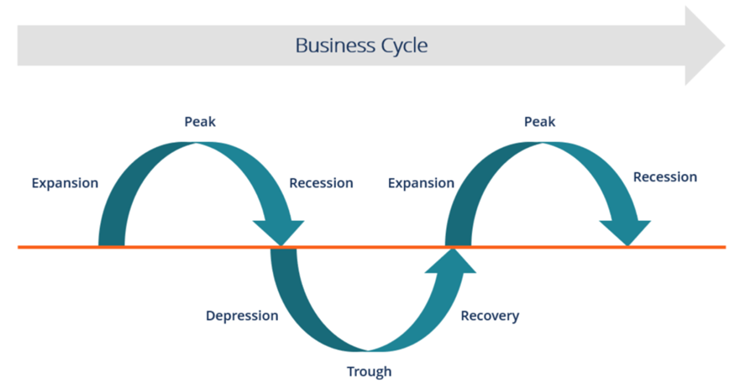
Business cycles

Before we focus on Real business cycle theory, it is necessary to understand what business cycles are. Business cycles can be described as fluctuating levels of economic activity of a country and refer to the ups and downs in aggregate economic economy. Burns and Mitchell (1946) defined business cycles as “a type of fluctuation found in the aggregate economic activity of nations”. You can observe such a business cycle on the following picture.

Business cycle can be divided into 6 phases

Expansion: It is the first stage. An increase in positive economic indicators can be observed here such as employment, production, output, wages, profits, demand and supply of products, and sales. This stage is characterised by debtors paying their debts on time, by the high velocity of the money supply as well as high investment.
Peak: The economy reaches the peak in that stage. The growth attains the maximum limit. Regarding the economic indicators, they don´t grow further because they are at their highest. Prices are situated at their peak as well. This business cycle stage represents the reversal in the trend of economic growth.
Contraction/Recession: This phase is characterised by rapidly and steadily declining demand for goods and services. Since producers don´t notice the decreasing demand instantly, they carry on producing which results in excess supply in the market. Prices start to fall as well as all positive economic indicators.
Depression: Unemployment rises in that phase while the growth keeps declining.
Trough: The prices of factors, as well as the demand and supply of goods and services, reach their lowest in that phase. This is the lowest the economy can go and represents the negative saturation point for an economy.
Recovery: This phase represents a turnaround from the trough. From this point the economy starts to recover. The recovery process keep continuing tills the economy returns to steady growth levels.

These 6 phases complete one full business cycle. The peak and the trough are the extreme points. Regarding real business cycle theory, it brings an assumption about the key drivers of these business cycle phases.

Real business cycle theory
As far as the present theory is concerned, the theory “specifies a dynamic stochastic general equilibrium model, which includes a specification of the stochastic process for the exogenous shocks that generate fluctuations in the model economy“. (Hansen, Gary D. &Ohanian Lee E., 2016)
In order to comprehend the real business cycle theory definition mentioned above, we will firstly focus on explanation of dynamic stochastic general equilibrium model also known as DSGE. The model is called dynamic because of involvement of time. The model takes into consideration the economy over time rather than only an isolated moment. The word “stochastic” stands for randomness built into the model. It corresponds to unexpected events to which probability can´t be assigned and that are characterised by truly uncertainty. Finally general equilibrium indicates that we take into account the system as a whole. Hence, it includes all markets in the economy. (Christiano, 2016)
Concerning the generation of fluctuations in the economy, according to Deng (2009), „the Real business cycle theory attributes aggregate output fluctuations to a large extent to the real shocks rather than nominal shocks to the economy. The real shocks can be understand as an unpredictable or unexpected event that can have both negative as well as positive effects on economy. Hence, the economic booms and recessions are seen by that theory as “efficient responses to exogenous changes in the real economic environment“.
All in all, the real shocks have big and far-reaching consequences on the economy. Regarding the sources of the changes having an impact on the fluctuations, McGrattan (2006) describes them as nonmonetary sources that include primarily changes in technology but also tax rates and government spending, tastes, government regulation, terms of trade, and energy prices“. Moreover, real shocks include wars and natural disasters such as floods, droughts and hurricanes as well. (Marginal revolution university, 2018)
Two principles of Real business cycle theory and its methodology
Real business cycle theory is characterised by two underlying principles: Firstly, we attribute a little importance to money in business cycles. Therefore, monetary shocks don´t have any significant power to make an explanation of aggregate output fluctuations. Secondly, business cycles are made by rational economic agents responding to real shocks optimally. Productivity growth is considered as the primary cause of fluctuations. However, it can be fluctuations in government purchases, import prices, or preferences as well. Hence, exogenous changes in the economic environment result in fluctuations.
Real business cycle methodology is characterised by two principles as well: Firstly, dynamic general equilibrium models, with rational expectations and expected utility maximization should always be used when modelling an economy. Secondly, we should take seriously the quantitative policy implications of a proposed model fitting the actual data. In particular, the quantitative technique known as “calibration” should be used when evaluating the suitability of the model for describing reality.
Regarding the methodology, it is considered as one of the most important contributions of the theory.

Examples of Real business cycle theory
Firstly, we will focus on the case when an exogenous increase in total factor productivity shifts the long run aggregate supply curve from AS to AS’. In the following graphic, we can observe the situation when aggregate supply increases, then total output increases as well.

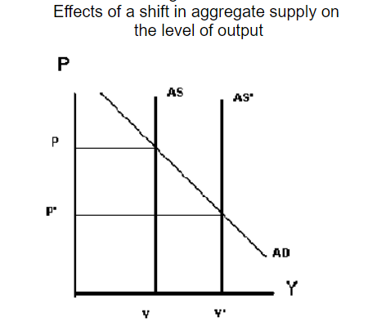

Regarding effects on the labour market, when aggregate supply is increased by real shocks, then labour demand increases. Hence, it does increases wages and the number of people working as well.

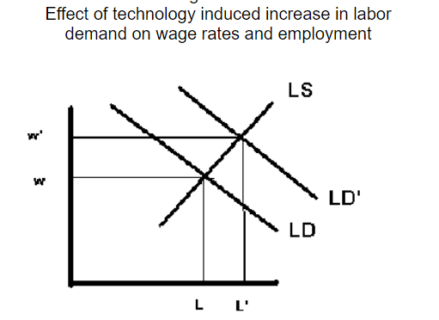

Concerning effects in the Capital Market, the higher level of economic activity increases the demand for capital which leads to a higher capital rental rate and capital utilization rate. Hence, more capital is used and corporate profits increase.

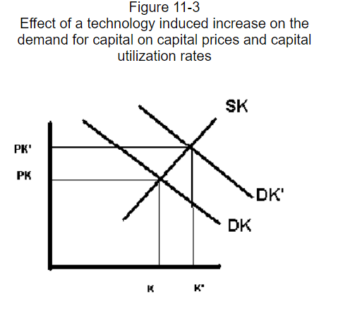

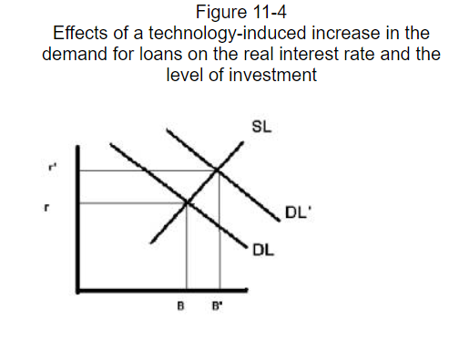
Last graph focuses on the impact on investment. It shows that when higher productivity increases the demand for loans. As a result, real interest rates grow as well as the amount of investment.

Critical Reflection on Real Business Cycle theory
The real business cycle theory has been controversial and influential since its first introduction. Despite the fact that the theory can explain most business cycles, it does contain a certain level of limitations. The main sceptical observations of real business cycle theory can be summarized in the following points:
Where are the shocks?
According to the theory, the driving for fluctuations are technological shocks. The theory interprets all movements in measured total factor productivity as the technological shock result. However, discussion of nature of these sources is missing. It seems complicated to interpret the absolute economic contractions that sometimes occur in the real world as a result of productivity shocks. (Summers H. Lawrence, 1986)
Interpretation of unemployment
Real business cycle theory´s assumption is that fluctuations in employment are fluctuations of changes in the amount of people who desire to work. They disagree with this assumption and believe that the desired employment is not so sensitive to real wages and the real interest rate. All in all, critics point out the fact that unemployment fluctuates substantially over the business cycle. (Economicsdiscussion, 2018)
Flexibility of wages and prices
Real business cycle theory is based on assumption that wages and prices are completely flexible. Hence, markets are always clear. Many critics argue that money wages and prices are inflexible. (Economicsdiscussion, 2018)
Neutrality of money
The theory assumes that money is neutral. Hence monetary policy is assumed not to affect real variables, such as output and employment. Many critics doesn´t accept Precott´s price-free economic analysis due to the conflict of the theory with the empirical evidence of the strong influence on the real economy of monetary policy. Critics argue that reductions of inflation and money growth are always associated with periods of high unemployment. (Economicsdiscussion, 2018)
Exchange failures
Another fundamental objection to this theory is that the fact, that partial breakdowns in the exchange mechanism are dominant factors in cyclical fluctuations, is ignored. (Summers H. Lawrence, 1986)
Correctness of the parameters
According to some critics, the real business cycle model is not an inconceivable representation of reality. Some critics find the parameterized model, which is supposed to be based on well-established microeconomic and long-run information, as not sustainable. (Summers H. Lawrence, 1986)
Summary
Real business cycle theory was introduced for the first time by Finn Kydland and Edward Prescott in 1982. The theory represented one of the most striking developments in the field of macroeconomics. Real business cycle theory is concentrated on aggregate output fluctuations. It attributes them to a large extent to the real shocks to the economy. According to this theory, exogenous changes in the real economic environment cause economic booms and recessions. The theory assumes that economic fluctuations are result of nonmonetary sources that include primarily changes in technology but also tax rates and government spending, tastes, government regulation, terms of trade or energy prices.
The real business cycle model is based on utility maximization and rational expectations. The proponents of the theory stands for the fact that output level in the economy maximizes the expected utility and therefore government should put emphasis on the long-term structural changes of the economy instead of interventions by fiscal or monetary policies to react to moderate the aggregate economic fluctuations. All in all, the main idea of real business cycle theory is that these cycles are „real“ and therefore represent reflection of the most efficient operations of the economy as well as the rationality of the economic agents.

Lucas curve model

Nobel Prize laureate in Economics in 1995 and advocate for economic liberalism, Robert Lucas Jr. is part of the new classical economics theory that wants to base its models on individual behaviors, which are the only ones not affected by economical politics on short term. He actually supports the general equilibrium theory but given the complexity of interactions, he chooses to reduce the general equilibrium to a few individuals (theory of rational expectations). He states that the various economic agents‘ information on the market is imperfect.
Keynesian paradigm of the 1960s is over, although some think it is arising again. What we used to call the revolution of rational expectations had given a severe jolt to the foundation of the discipline. Still through distinctive times

It is a critic of the Keynesian theory and mostly of the Phillips curve, that shows that the choice of macroeconomic politics is based on the relationship and arbitrage between the unemployment rate and the inflation rate. Yet, Lucas demonstrates through his approach of rational behaviours, that the agents take into account, in their forecasts, the measures of economical politics announced, so that the expected effects will not come true. In that case, the great macroeconomic models which are measured according to previous observations can not help estimate the consequences of economical politics.
According to the theory supported by Lucas and the neoclassical economists, economical politics are inefficient.

For classical economists, the equilibrium is determined by the price between demand and supply (equilibrium price). This model only exists in a pure and perfect competition model, which is a theoretical market structure in which the following five criteria are met:
1-A large number of buyers and sellers
2-All firms sell an identical product (the product is a "commodity" or "homogeneous")
3-Freedom of entry and exit on the market
4-Resources such as labor and goods are perfectly mobile
5-Buyers have complete or "perfect" information – in the past, present and future – about the product being sold and the prices charged by each firm
In the classic theory (with Friedman for example), and now the new classical economics we focus on rational expectations: if at a given moment, the behavior of an agent depends on a distribution of subjective probabilities of the future value of the exogenous and endogenous variables of the model. This distribution is the same than the realdistribution, conditional to the information available at that moment.
Macroeconomic phenomena are described as the result of the buyers and sellers microeconomic decisions. It is considered that all the agents make individual optimal decisions according to the limited informatino they are given. Those decisions are the outcome of rational expectations, but as Lucas shows, those do not prevent from misjugements.
Imperfect information: for Robert Lucas in the early 1970s, the sellers have a better overview of their own prices than of those in the economy as a whole and they often confuse the rise of the general level of prices with a slight rise of the prices of their own products. Therefore they react to a monetary expension by increasing their offer of supply, until they realise their mistake.This is due to a lack of information and not to an irrational decision.
Structure of chapter
Through the new classical economics theory of equilibrium analyse and of supply, Lucas came up with the islands model. Where Robinson Crusoë is isolated on an island and experiences a sudden increase in the coconut harvest. Lucas assumes Robinson’s possible rational reactions modelded by equations:
If y(t) is the production’s logarythm, Y(t), p(t)the price level loharythm,P(t), the supply curve is written:
Y(t)=α [ p(t) – E_{t-1} (p(t)) ] + βy (t-1) + γ
Lucas hypothetically assumes isolated sellers, each on an island, z. The production on z positively depends on the gap between pz(t), the price on date t of the product on z, and Ez (p(t)) the perception (expectation) on z of the general indicator of prices p(t). It implies:
P_{z} (t)= p(t) + e_{z}(t)
Where e_{z}(t) is a „white noise“ independant of pz(t), so that
$\sum_{\begin{aligned}ez \\ z\end{aligned}}^{ }{\left(t\right)=0}$
In that case the minimum variance estimation is:
E_{z} (p(t)) = ap_{z} (t) + (1-a) E_{t-1} (p(t)) where a= $\frac{v(e)}{v\left(e\right)+v(p)}$
If v(x) represents the variance of the x population. Summing up on z, comes:
y(t)=λ$\sum_{\begin{aligned} \\ z\end{aligned}}^{ }{\left(pz\left(t\right)-Ez\left(p\left(t\right)\right)\right)=λ\left(1-a\right)(p\left(t\right)-E}$_{t-1} (p (t))))

Lucas also thought of the equilibrium and anticipation error model, which implies the short term equilibrium of the goods and labour markets (3 markets: goods, labour and monatary). The variables q and n are respectively lagarithms of the production and the labour, w, p and m are logarithms to the nominal wage rate, the general level of prices and the monetary mass. Constant terms and capital stock are constant on short term, and are therefore ignored. The model can be summarised by four equations:

q=αn | Production function
n^{d}=-(1-α)(w-p) | Demand for labour / supply for goods q^{s}=αn^{d}
n^{s}=β(w-p) | Supply for labour
q^{d}=δ(m-p) | Demand for goods

The labour market equilibrium (n^{d}=n^{s}) determines the real wage and the work, and the production is deducted through the production function (1). Here the Walras equilibrium solution is (n=q=w-p=0). Then, the exogenous monetary mass m determines the general level of prices through the equilibrium of the goods market (fourth equation with q^{d}=q^{s}=0) and the nominal salary is deducted from it (p=w=m). A monetary policy ora choc affecting the demand will not have real effects.

The imperfect information
If the model is modified, assuming that the supply of labour is function to prices p*, anticipated by employees:
(3) n^{s}=b(w-p*)
The labour market equilibrium (n^{s}=n^{d}) leads then to a choice between inflation and unemployment or a choice between price p production volume q:
(5) q=ε(p-p*) with ε=$\frac{αβ(1-α)}{β+(1-α)}$
If employees expectations are adaptative (p* fixed), a monetary politic or a choc of demand have a simultanous effect on the production volume and the prices. By solving (4) and (5), is obtained:
(6) q=$\frac{εδ}{δ+ε}(m-p*)$
However, when employees anticipate perfectly the price evolution (p=p*), the equilibrium model is restored (the supply curve shows q=0).
Rational expectations
Let’s assume that supply and demand result from relations between (4) and (5) and uncertain chocs of zero average value, without time correlation u_{t} and v_{t}:
(5‘) q_{t}=ε(p_{t}-p_{t}*)+u_{t} Friedman-Lucas supply function
(4‘) q_{t}=δ(m_{t}-p_{t})+v_{t} Demand, IS/LM
Eliminating p_{t} between (4) and (5) a reduced form is obtained:
(6‘) q_{t}=$\frac{εδ}{δ+ε}$(m_{t}—p_{t}*)+$\frac{εvt+ δut}{ε+δ}$
Rational expectation of prices is obtained by taking the mathematical expectation of (4) and (5), from which is deducted:
(7) p_{t}*=E(p_{t} | t-1)=E(m_{t} | t-1)
By reporting p_{t}* in (6‘), q_{t} is obtained:
(8) q_{t}=$\frac{εδ}{ε+δ}$(m_{t}-E(m_{t} | t-1))+$\frac{εvt+ δut}{ε+δ}$
On one hand, we observe that only unexpected policies [E(m_{t} | t-1) ≠ m_{t}] affect the production, and on the other hand that economical fluctuations result from either expectation errors or uncertain chocs.
Fluctuation persistency
Production fluctuations given by relation (8) have no correlation to time. The model can therefore not describe the fluctuations persistencies. If the demand’s fluctuations had an effect on time correlation, this autocorrelation would be taken into account in E(p) and would have no impact on the production.

Summary
Lucas has emphasised the issue of how people form expectations of the future. expectations play a crucial role in the economy because they influence all sorts of economic behaviour. Households decide how much to consume based on expectations of future income, and firms decide how much to invest based on expectations of future probability. These expectations depend on many things, including the economic policies being pursued by the government. Lucas has argued that traditional methods of policy evaluation do not adequately consider this impact of policy on expectations and, thereby on behaviour.

List of references
Dornbusch, R., Fischer, S., Startz, R. (2010) Macroeconomics (11th ed.). McGraw-Hill.
Jochumzen, P. (2014) Essentials of Macroeconomics (1st ed.). Bookboon.com.
CNB. What is inflation? [online]. [cit. 2019-01-04]. Available on: https://www.cnb.cz/en/faq/what_is_inflation.html
CZSO. Inflation – Types, Definition, Tables [online]. [cit. 2019-01-05]. Available on: https://www.czso.cz/csu/czso/inflation_rate
CZSO. Inflation, Consumer Prices [online]. [cit. 2019-01-04]. Available on: https://www.czso.cz/csu/czso/inflation_consumer_prices_ekon
EconomyWatch. Inflation And Fiscal Policy [online]. [cit. 2019-01-04]. Available on: http://www.economywatch.com/inflation/economy/fiscal-policy.html
Finance.cz. Fiskální politika [online]. [cit. 2019-01-06]. Available on: https://www.finance.cz/makrodata-eu/statni-rozpocet/fiskalni-politika/
The Balance. Fiscal Policy Types, Objectives, and Tools [online]. [cit. 2019-01-05]. Available on: https://www.thebalance.com/what-is-fiscal-policy-types-objectives-and-tools-3305844
Wordpress. Public Finance – Basic concepts [online]. [cit. 2019-01-06]. Available on: https://abhijeetgautam.wordpress.com/2015/06/22/public-finance-basic-concepts/
Lieberman, M. and Hall, R. (2005) Principles and applications of macroeconomics (international student edition). Thomson south-western
Samuelson, P. and Nordhaus, W. (1989) Macroeconomics (13th edition). McGraw-Hill book company.
Corporate finance institute, GDP Formula. Consulted the 15th of December 2018 via https://corporatefinanceinstitute.com/resources/knowledge/economics/gdp-formula/
Investopedia, Net investment. Consulted the 15th of December 2018 via https://www.investopedia.com/terms/n/netinvestment.asp
Numilog. Consulted the 15th of December 2018 via https://www.numilog.com/package/extraits_pdf/e239544.pdf
Study.com, foreign investment. Consulted the 15th of December 2018 via https://study.com/academy/lesson/what-is-a-foreign-investment-definition-examples.html
World economics, GDP. Consulted the 15th of December 2018 via https://www.worldeconomics.com/Pages/Gross-Domestic-Product.aspx
HYMAN, D.N. (1989). Chapter 29: The Components of Aggregate Demand. In: Hyman, D.N. Economics. Homewood: Richard D Irwin
Investopedia: Consumption function [Online]. (2017). Retrieved December 21, 2017, from https://www.investopedia.com/terms/c/consumptionfunction.asp
JUREČKA, V. CSC., a kolektiv.(2010). Makroekonomie; 1. vydání, Praha: Grada Publishing, a.s., ISBN 978-80-247-3258-9.
SAMUELSON, P., NORDHAUS W. (2001). Economics. Boston MA: McGraw Hill

Khan, S. (2011). Aggregate demand and aggregate supply. Khan Academy. Retrieved December 16, 2017, from: https://www.khanacademy.org/economics-finance-domain/macroeconomics/aggregate-supply-demand-topic

OpenStax (2016). Principles of Macroeconomics, 11.2 Building a Model of Aggregate Demand and Aggregate Supply. OpenStax Economics. Retrieved December 16, 2017, from: https://cnx.org/contents/QGHIMgmO@10.235:qPYFpWfb@10/Building-a-Model-of-Aggregate-

Investopedia, LLC. Aggregate supply. Retrieved December 20, 2017, from: https://www.investopedia.com/terms/a/aggregatesupply.asp
CliffsNotes (2016). Aggregate supply (AS) curve. Retrieved December 20, 2017, from: https://www.cliffsnotes.com/study-guides/economics/aggregate-demand-and-aggregate-supply/aggregate-supply-as-curve
EconomicsHelp (2016). Difference between SRAS and LRAS. Retrieved December 20, 2017, from: https://www.economicshelp.org/blog/2860/uncategorized/difference-between-sras-and-lras/
SparkNotes (2017). Aggregate supply. Retrieved December 20, 2017, from: http://www.sparknotes.com/economics/macro/aggregatesupply/section3.rhtml
Khan, S. (2011). Aggregate demand and aggregate supply. Khan Academy. Retrieved December 16, 2017, from: https://www.khanacademy.org/economics-finance-domain/macroeconomics/aggregate-supply-demand-topic
OpenStax (2016). Principles of Macroeconomics, 11.2 Building a Model of Aggregate Demand and Aggregate Supply. OpenStax Economics. Retrieved December 16, 2017, from: https://cnx.org/contents/QGHIMgmO@10.235:qPYFpWfb@10/Building-a-Model-of-Aggregate-
Investopedia, LLC. Aggregate supply. Retrieved December 20, 2017, from: https://www.investopedia.com/terms/a/aggregatesupply.asp
CliffsNotes (2016). Aggregate supply (AS) curve. Retrieved December 20, 2017, from: https://www.cliffsnotes.com/study-guides/economics/aggregate-demand-and-aggregate-supply/aggregate-supply-as-curve
EconomicsHelp (2016). Difference between SRAS and LRAS. Retrieved December 20, 2017, from: https://www.economicshelp.org/blog/2860/uncategorized/difference-between-sras-and-lras/
SparkNotes (2017). Aggregate supply. Retrieved December 20, 2017, from: http://www.sparknotes.com/economics/macro/aggregatesupply/section3.rhtml
Macroéconomie comtemporaine, Vivien Lévy-Garboua & Bruno Weymulle, 1981
Théorie et modélisation macro-économiques, d’hier à aujourd’hui, M De Vroey, P Malgrange, Revue française d’économie, n°21-3, (p3-38), 2007
Principes d’économie moderne, J E Stiglitz, JD Lafay C E Walsh, de Boeck Supérieur, Ouvertures Economique, 2014
Macroéconomie, Jean-Luc Bailly, Gilles Caire, Christophe Lavialle, Jean-José Quilès - Collection Grand Amphi - Economie, Bréal, 2006

