1. What do you say to express the situation in the picture? Tick the right option(s) ( / 8):
 | 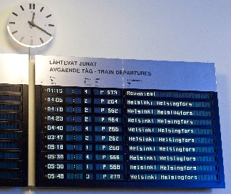 |  | 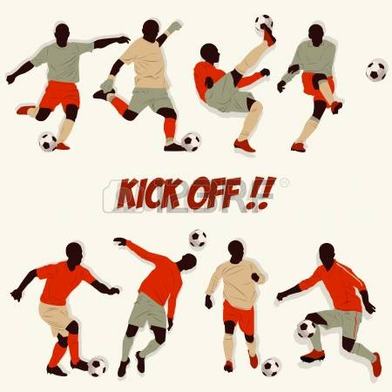
Wait, I’m going to help you. | The Helsinki train is going to leave at 04:18. | Oh, you are going to make vegetable salad (100%). | Who do you think is going to win?
Wait, I’m helping you. | The Helsinki train is leaving at 04:18. | Oh, you are making vegetable salad (70%). | Who do you think is winning?
Wait, I’ll help you. | The Helsinki train will leave at 04:18. | Oh, you will make vegetable salad. | Who do you think will win?
Wait, I help you. | The Helsinki train leaves at 04:18. | Oh, you make vegetable salad. | Who do you think wins?

2. Complete the following conditional sentences ( / 12):
- Come on, John! You will miss (miss) the train if you don’t hurry (not hurry).
- Shame, I don’t have enough money. If had (have), I would buy (buy) a new speakers.
- It’s raining, so we’re not going out. We would get wet (get wet) if we went out (go out).
- I must go and see Ann sometimes. Actually, if I have (have) time, I will go (go) today.
- It’s not a very nice place. I wouldn’t go (not go) if I were (be) you.
- If the weather is (be) right, we always go (always go) for a trip in the mountains.

3. Finish the sentences in an appropriate way ( / 8): různé možnosti - časy dodržet!
- If I won a million, I’d buy a new house.
- If the roads are wet, there are more accidents.
- If I graduate this year, I will take a year off to travel around the world.
- I get very tired, if I work hard all day.

4. Make responses as indicated. Write more options where possible: ( /12):
- “I have never been to India” - You (-): I haven’t been to India, either. / Me neither. /
Neither have I.

- “She’s got a dog” - You (-): I haven’t.

- “They will get married sometime” - You (+): I will get married sometime, too. / Me
too. / So will I.

- “I don’t understand!” - You (+): I do.

5. Correct the errors: ( /12):
- Will you go to the party on Saturday, if they invite you?
- I arrived in Russia 2 years ago.
- She has never been to India.
- She hasn’t visited them yet.
- Look at those clouds. It is going to rain.
6. Put in a relative pronoun where necessary: ( /10):
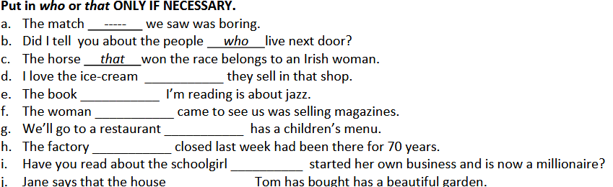
d) Ø, e) Ø, f) who/that, g) which/that, h) which/that, i) who/that, j) Ø

7. Describe the following people. What do they look like? ( /16):

 | She is tall and slim. She’s got brown middle-length wavy hair.

 | He is very tall and slim. He is bold and has got a big nose. He’s got large fingers.

 | She is of medium height and very thin / skinny. She’s got fair medium-length hair and long arms. She is very pale.

 | She is quite short and slim. She has got long brown curly hair, short fingers and small feet.

8. Correct the errors in these sentences. ( /12):
a. Joan won the prize, which surprised me a lot.
b. The children that were playing football broke one of my
windows.
c. The house in which I was born has just been demolished.
d. Fred is the man who lives next door.
e. The books which are on the table are mine.
f. I can’t remember the name of the person who I borrowed this pen from.

9. Label with the correct word ( /10):
 hitchhike suitcase
 gale  signpost
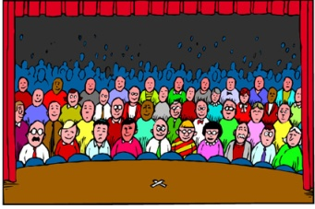 audience  cartoon

 martial arts 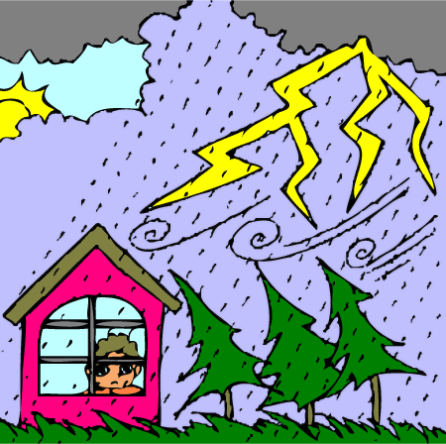 thunderstorm

 patterns formed by frost  striped

