

Macroeconomics 2

Moodle blocks 8

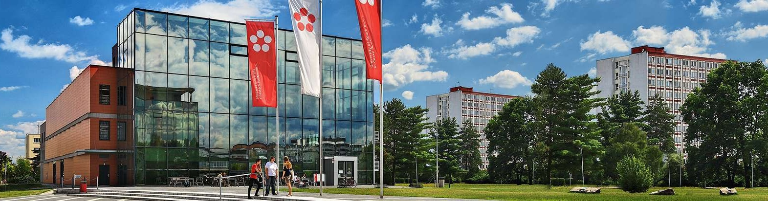

Jihočeská univerzita v Českých Budějovicích

Branišovská 1645/31a

370 05 České Budějovice

IČ: 60076658

# Model IS - LM

# **Y = 1/k *(M/P +hi) (i = 1/h * ( k Y - M/P) (3 sektor)**

**M/P = kY – hi**

**Y = 1/k *(M/P +hi)**

1. Economic data are

C = 250 +0.8 YD, t = 0.25, Ga = 460 bl, I = 300-1 000 i, M / P = 900 bl, L = 1Y - 10000 i

TAa = 500 billion TRa = 125

a) Write the equations of the IS and LM curves

b) What is the starting level of the equilibrium product, interest rate and investment?

c) show the graphical situation

1. The economy is described by:

C = 100 + 0,8 YD t = 0,25 I = 1000 - 200 i Ga = 340 TRa = 30 L = 0,2Y - 300 i M = 850

   P = 1.25. TAa = 0

Find out if at the NH level of the product Y = 4000 and the interest rate i = 0,15 is

a) there is a balance in the goods market

b) Balance of money market

1. Graphically illustrate Y change in IS - LM model and change i if it occurs:

• to reduce the tax rate (t)

• increased money supply in the economy (M / P)

• increase in government spending (Ga)

1. We know the following:

C = 100 + 0.8YD t = 0.15 I = 600-2000i G = 600 L = 0.3 Y - 5000i M / P =? ; Tra, TAa = 0

Specify the value of the real money offer if the value of the equilibrium product is Y = 4000

1. The economy is described by the following:

  M / P = 400 I = 700-1000i C = 300 + 0.7 YD t =? G = 500 L = 0.32 Y - 6000i Tra, TAa = 0

a) Specify the tax rate if the value of the product is Y = 3500

b) Graphically illustrate the situation