

Macroeconomics 2

Moodle blocks 12

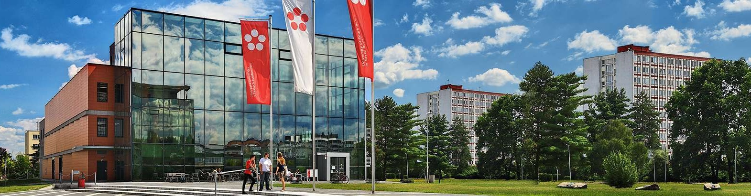

Jihočeská univerzita v Českých Budějovicích

Branišovská 1645/31a

370 05 České Budějovice

IČ: 60076658

Consumption (the theory of life cycle)

1. Young hopeful graduate Maruška of the prestigious University of South Bohemia, will start working at the age of 25 with the initial value of its assets 0. He retires at the age of 65 and dies at age 75. Avg. the working income is CZK 0.40 million.

Find out:

(a) the proportionality ratio

(b) what is the annual planned level of consumption,

(c) the level of lifetime consumption expenditure

(d) the size of lifetime earnings

e) Calculate the maximum asset level

f) What will be the marginal propensity to consume from wealth in the first year of work and in the year

retirement.

g) what will be the marginal propensity for consumption from the labor income in the first year of work and at 35 years.

1. The young promising graduate PEPA will start working at the age of 20 with the initial value of its property in the form of building savings from parents of CZK 200,000. He retires at the age of 68 and dies at a heart attack at age 78. Avg. the working income is CZK 0.35 million.

Find out:

(a) the proportionality ratio

b) What is the marginal propensity for consumption from wealth in the first year of work and at age 40?

c) what will be the marginal propensity for consumption from the labor income in the first year of work and at the age of 40?

(d) lifetime consumption in 30 years

12. Consumption ( the theory of consumption and permanent income)

what is the basic concept of permanent income theory

*** ***

1. Determine whether changes are permanent or temporary

(a) farmers, due to the good weather, will increase their production and consequently profit by 20%

(b) thanks to the acquisition of a milking robot, farmers will increase profits by 5%

c) Employer increases employee wage rates by 5% due to higher labor productivity

d) Employer pays to each employee, based on the results of the last year, a one-time share of profit of 19 thousand. CZK.

e) dentists have improved the average number of patients by 2%

1. Mr. Pepa starts working as a plumber at the age of 20 after a high school, retiring at the age of 65, and his death scheduled for 80 years.

Specify an increase in average annual consumption

a) if the firm employs Pepa's firm for the first year to pay a one-time annual reward of 10,000

b) if the firm will increase its basic annual wage rate by 10,000 for the first year

Graphically illustrate Mr Pepi's long-term and short-term consumer service as Mr Pepa receives a monthly wage of CZK 20,000. Then, in May, he will receive a one-time reward of CZK 5,000.