

Macroeconomics 2

Moodle blocks 7

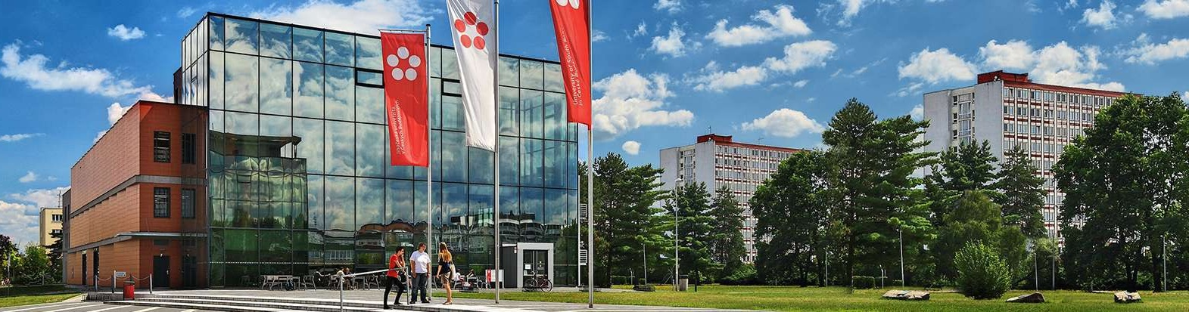

Podtitul dokumentu

Jihočeská univerzita v Českých Budějovicích

Branišovská 1645/31a

370 05 České Budějovice

IČ: 60076658

2. Model LM (in the three-sector model of the economy)

Demand for money L = kY - hi k,h> 0 Money supply (real) = M / P

kY - hi = M / P

k - coefficient of sensitivity of demand for money to the amount of the income

h - coefficient of sensitivity of demand for money to the level of the interest rate

Which institutions manage the money supply in the Czech Republic?

What tools does it have to do with it?

What shows the LM curve and what is the slope of the LM curve?

Describe the general definition of the LM curve

The economy is described by the following:

  k = 0.5 h = 7500 M = 825 P = 1.1

a) What is the equation of demand for real money balances

b) Determine the equilibrium interest rate at Y = 2100

c) Display graphically the situation

The demand for money function is given by the relation L = 0,25Y - 100i

(a) what must be a real money supply so that the NH product Y = 3000 and the interest rate i = 0,15 are balanced on the money market?

b) What must be the money supply for this same NH product if the monetary demand sensitivity parameter against NH product is increased by 0.02 and if the interest rate in i = 0.15

The demand for money function is given by L = 0.25Y-100i

(a) what must be a real money supply M / P so that for Y = 2000 the equilibrium interest rate i = 0,2

(b) what money should be offered for this NH product if the demand-sensitivity parameter for the NH product is increased by 0.02 and the equilibrium interest rate i = 0.2

c) What value will the equilibrium interest rate change if the original money product of a) would, on the contrary, maintain the money supply?