

Macroeconomics 2

Moodle blocks 3

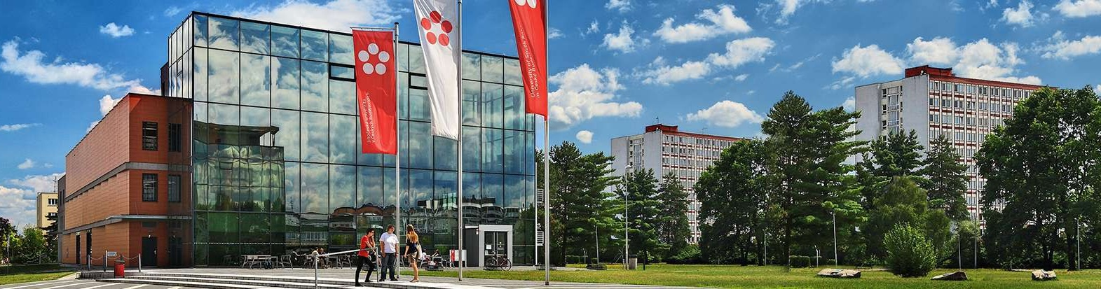

Podtitul dokumentu

Jihočeská univerzita v Českých Budějovicích

Branišovská 1645/31a

370 05 České Budějovice

IČ: 60076658

# Three-sector model of economy

**AD = Y AD = C + I+ G AD = Ca + c*YD + Ia + Ga**

**C = Ca + c ( Y – TAt+ TRa)**

**C= Ca + c*(Y-t*Y-TAa+TRa ) TAt- total taxes TRa – transfer payments**

**1 Tat = t*Y + TAa**

**α 3= -----------**

**1-c (1-t)**

**BS =** *budget surplus*

**BS = (t*Y + TAa) - (TRa+Ga)**

11. Identify the three main actors in the closed economy.

12. How is the slope of the AD curve in the three-sector economy model affected?

13 A. What happens to a three-sector curve if the income tax (personal income tax) increases from 20% to 25%?

13 B What are the two most common tax options in the world from the point of view of direct taxes?

14. What part of the tax revenues has in recent years the largest share of the revenues of the state budget of the Czech Republic?

15. Jaká jsou základní fiskální pravidla (konvergeční pravidla) pro vstup do Eurozóny

What are the basic fiscal rules (convergence rules) for entering the Eurozone?

16. The following data about the closed economy are known.

  C = 300 + 0,8YD I = 100 t = 0,25 TRa = 300 Ga = 480 TAa = 100

a) calculate the equilibrium NH product in both possible ways

b) determine whether the state budget is balanced at equilibrium in the final goods market

c) determine the share of SR deficit in GDP in %

17. Economy is characterized by autonomous investments I = 600, state expenditures Ga = 660, marginal propensity to consume c = 0,8, autonomous consumption Ca = 140, tax rate of income t = 0,15, value of transfer payments (TRa) = 80 and autonomous taxes (TAA) = 30. Find out:

a) the composite alpha multiplier value and the equilibrium level of the NH product

b) whether the state budget is balanced in the achieved NH product

c) if not, what tax rate and level of state government expenditure to choose in order to balance the state budget in the situation when the product is in equilibrium

18. Which expenditure has the largest share of the total state budget expenditures in the Czech Republic?

19. The economy is characterized by the following relationships:

     C = 500 + 0,6 Yd I = 600 G = 650 t = 0,15 TR = 30 TAa = 20

  Find out

a) an equilibrium NH product

b) the level of consumption expenditure C

c) of what value must the tax rate t be changed if the economy is to reach the potential product level Y = 4000

d) Graphically illustrate this situation