**COSTING - Example**

**Solution Example**

The “ŠIK” tailor shop has two business establishments, the shop for sewing of ready-made clothing and a shop for sewing of car seat covers. In the tailor shop for ready-made clothing, the seamstresses also make:

* + **Trousers** - the annual production target is **316 items**;
  + **Suit**  - the annual production target is **280 items.**

according to the technical and administrative standards, the direct material (fabric, Flizelin, threads, zippers, buttons) and direct wages (piece work pay of the seamstress) per item:

**Trousers:** direct material 200 CZK and direct wage 250 CZK,

**Suit:** direct material 350 CZK and direct wage 200 CZK.

**Annual production overheads budget** (depreciation of sewing machines, scissors, iron, chalk, pins, electric power consumption):

* + tailor shop for ready-made clothing - 150,000 CZK
  + tailor shop for car seat covers - 280,000 CZK

**Annual administration overheads budget** (salary of the accountant, manager, interest on loans, administrative costs) for the whole company (both workshops) amount to 700,000 CZK. The direct cost annual budget for the rest of the clothes from the tailor shop for ready-made clothes is 449,700 CZK. The direct cost annual budget of the tailor shop for car seat covers is 6,250,500 CZK.

Task: Compile the preliminary costing of the two selected products (**trousers, suit)** assuming that the scheduling base for determination of the production and administrative overheads is the total of direct costs.

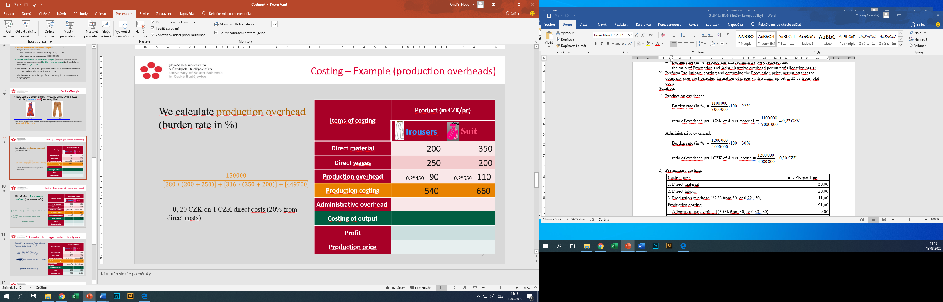

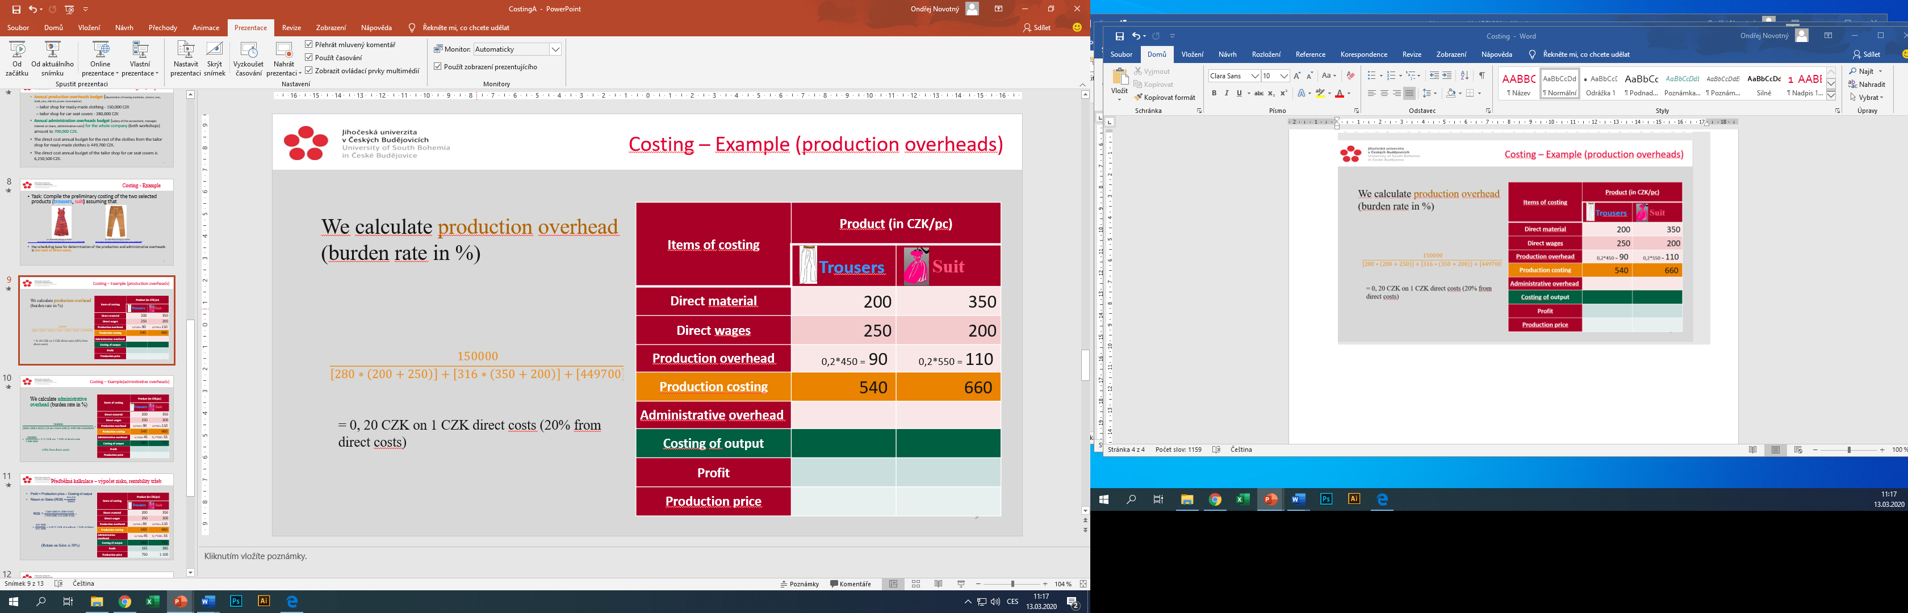

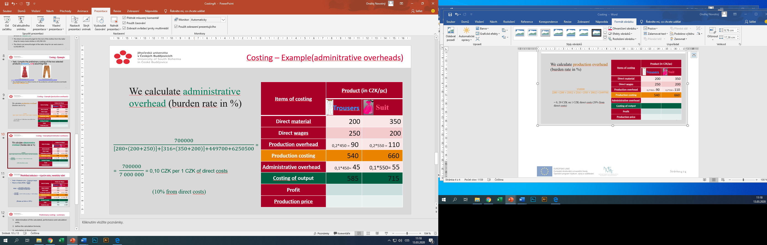

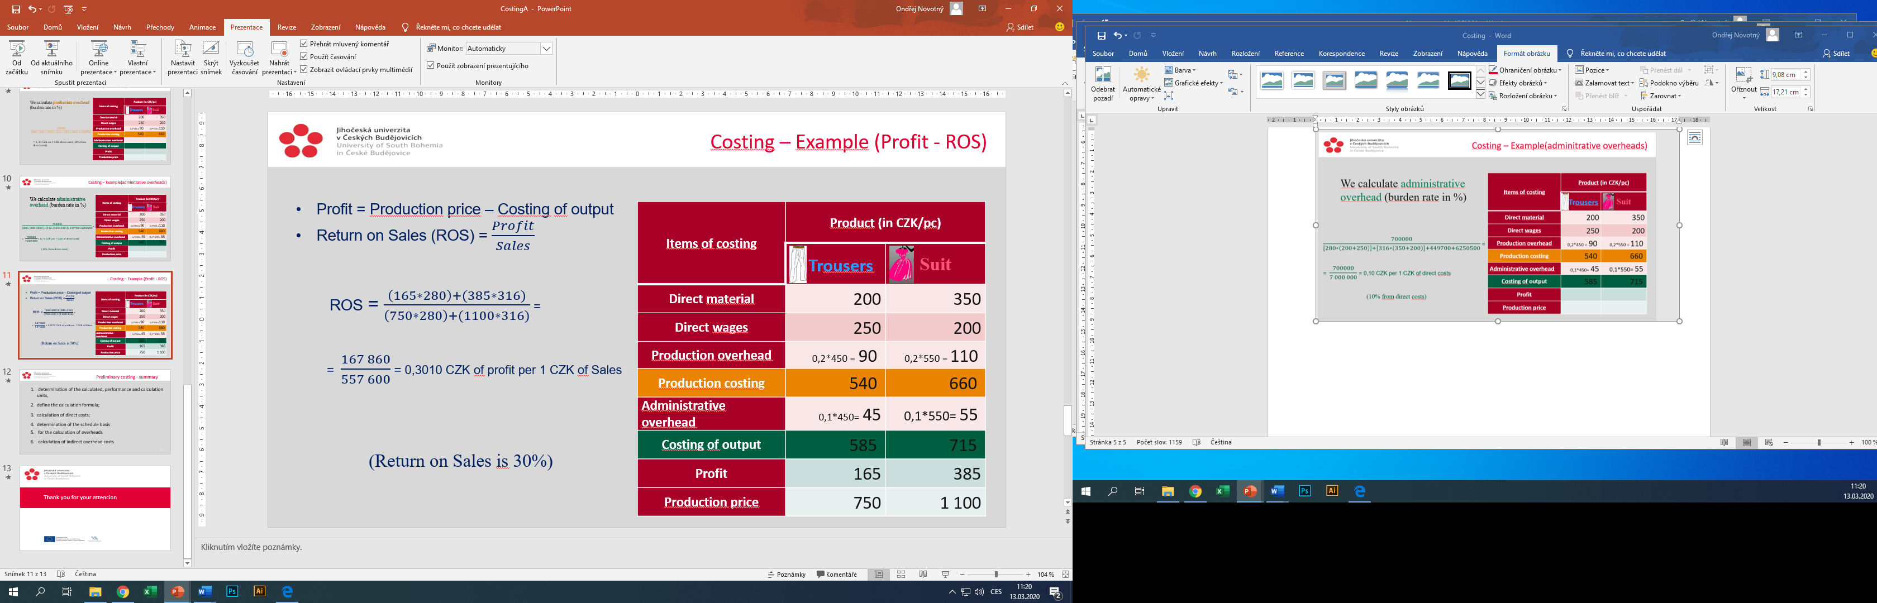

**The procedure for costing** is as follows:

1. determining calculated outputs and cost units, defining costing scheme;
2. calculation of direct costs;
3. calculation of indirect overhead costs;
4. calculation of costs per cost unit.

**Example to praktice:**

A textile manufacturing company’s annual budget of production overhead for its main production is 2 604 000 CZK. The administrative overhead has an annual budget (allotted to main production) of 1 736 000 CZK. The annual volume of planned direct labour is 2 480 000 CZK.

The cloth being produced in January has a standard for consumption of yarn set at 300 g per 1 m (a regular metre, 1,40 m wide), the yarn being priced at 120 CZK per 1 kg. The standard for direct labour of weavers and other production workers is 5,00 CZK per 1 m of cloth.

Assignment:

1. Calculate:

* Burden rate (in %) Production and Administrative overhead, and
* the ratio of Production and Administrative overhead per unit of allocation basis

using Direct labour for Allocation Basis.

1. Calculate Preliminary costing per 1 m of cloth.

Solution:

Preliminary costing per 1 m of cloth:

|  |  |
| --- | --- |
| Costing item | in CZK per 1 m |
| 1. Direct material |  |
| 2. Direct labour |  |
| 3. Production overhead |  |
| Production costing |  |
| 4. Administrative overhead |  |
| Costing of output |  |