**The Change Management Process**

This research aims to describe the change management process, which plays very important role in every successful organization. For better understanding of the Change Management Process, first, the key components - change and change management terminology is shortly defined. Then it is followed by the change management process definition. This paper is based on review of literature gained from books, and academic journal articles published by international platforms such as EBSCO, Scopus or JSTOR.

**Change**

A change is defined as any activity that transitions a known state to a new desired state and the actions required to obtain the desired result. (Figliomeni, 2012)

Change is an ongoing natural process. For a successful organization, change is meant to be implemented at three different levels, i.e., individual, group and organization. At every level of change, leadership plays different role as it’s the virtual duty of a leader to manage the people and make their efforts to be at their best in favor of change for an organization. Change management is an essential area of concentration for the healthy growth of any business, it is important even for the survival of any organization in today’s business world. Successful change in any organization is impossible without the active participation of management. (Ajmal, Farooq, Sajid & Awan, 2012)

**Change Management**

Change Management is to study directing the organization, including the organizational, communication, information, and personnel. A differentiated and integrated change management deals with problems of strategic management, organizational, human resources, as well as those related to communication and information. Change Management is part of organizational change and, on the other hand, some individual change. There is no universal approach to change management. Each unit should evaluate their unique culture and responsiveness to change and develop a change management strategy based on this profile. (Barcan, 2010)

Managing change is a process that begins with awareness of the need for change. Analysis of this situation and the factors that caused it, leads to the diagnosis of its specific characteristics. Subsequently, is the direction determined in which further steps will be taken. It is also necessary to decide what roads will be chosen so that the organization has received in the desired position. Just the transition period is a critical stage in the process of change. There are emerging problems introducing changes concerning, for example some people’s resistance to change, low stability, high stress levels, energy focused in the wrong direction, the emergence of conflicts, loss of incentives and the like. It is therefore important to anticipate reactions and likely barriers to the introduction of change. (Pohanková, 2010)

**The Change Management Process**

Change Management is a business process like any other that a company carries out. This means that clearly defined targets and a strategy are required to achieve a goal for change. A business process is based upon a specific organizational structure, a clear definition of relevant functions and data, it can be controlled and be illustrated clearly. Treating Change Management as a process also allows to measure the result. (Abolhassan, Jost, Kirchmer & Scheer, 2003)

The organization needs to clearly define the aims and strategy of the change to be made. This definition must be supported by the promoters and stakeholders of the company to lead to the desired change. The aims and strategy for the change should be managed by a specific functional entity - or Change Team. This Team must establish a clear, transparent and bi-directional information flow that is mandatory for the entire company and team. The newly changed and improved process must then be implemented and actively carried out within the company. In order to do this, the relevant target group also needs to be trained. (Abolhassan, Jost, Kirchmer & Scheer, 2003)

The Change Management Process is the key to successful change. Understanding and following the process guarantee success in any personal or business change people choose to manage. All too often, people involved or affected by change don’t have a clear understanding of what’s happening. The fail to see where they are, where they are going, and when the transformation will be complete. That’s a recipe for disappointment. (Lister, 2005)

This is the reason, why this process really requires a clear communication plan including key messages, relevant communication channels, appropriate media types, e.g. newsletter, Intranet, platforms, frequent contact, binding time schedules and the possibility for feedback. This allows for the involvement of all employees, ensures a high quality of change and increases the level of acceptance. (Abolhassan, Jost, Kirchmer & Scheer, 2003)

There exists in the literature several change models to guide and instruct the implementation of major change in organizations. Three of the most well-known are Kotter's strategic eight-step model for transforming organizations, Jick's tactical ten-step model for implementing change, and General Electric (GE)'s seven-step change acceleration process model. (Mento, Jones & Dirndorfer, 2010)

This paper first introduces Kotter's strategic eight-step model followed by two more examples of change management process models.

Figure 1: 8-Step Process (www.kotterinc.com)

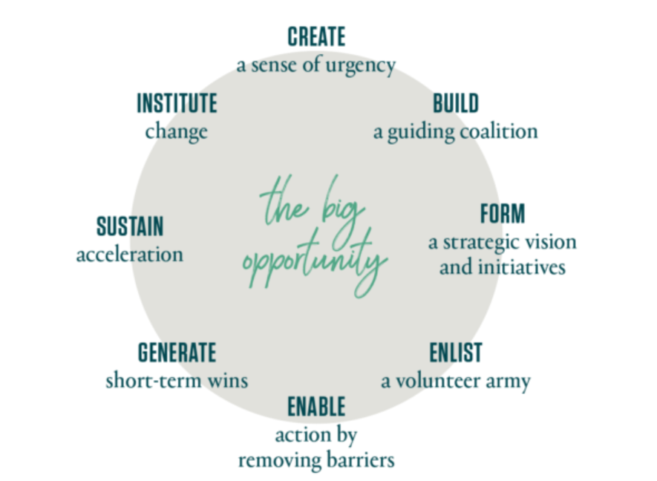

Kotter International (2018) define 8 Steps for Leading Change:

* **STEP 1 - Create a Sense of Urgency**

The top leaders must describe an opportunity that will appeal to individuals’ heads and hearts and use this statement to raise a large, urgent army of volunteers.

* **STEP 2 - Build a Guiding Coalition**

A volunteer army needs a coalition of effective people — coming from its own ranks — to guide it, coordinate it and communicate its activities.

* **STEP 3 - For a Strategic Vision and Initiatives**

Dr. Kotter defines strategic initiatives as targeted and coordinated "activities that, if designed and executed fast enough and well enough, will make your vision a reality."

* **STEP 4 - Enlist a Volunteer Army**

Large-scale change can only occur when very significant numbers of employees amass under a common opportunity and drive in the same direction.

* **STEP 5 - Enable Action by Removing Barriers**

By removing barriers such as inefficient processes or hierarchies, leaders provide the freedom necessary for employees to work across boundaries and create real impact.

* **STEP 6 - Generate Short-Term Wins**

Wins are the molecules of results. They must be collected, categorized, and communicated — early and often — to track progress and energize your volunteers to drive change.

* **STEP 7 - Sustain Acceleration**

Change leaders must adapt quickly in order to maintain their speed. Whether it's a new way of finding talent or removing misaligned processes, they must determine what can be done — every day — to stay the course towards the vision.

* **STEP 8 - Institute Change**

To ensure new behaviors are repeated over the long-term, it's important that you define and communicate the connections between these behaviors and the organization's success. (Kotter International, 2018)

**The Change Management Process Model** according to Lister (2005) consists of four distinct phases, broken into a total of eight steps.

It is a simple but powerful sequence of four phases – **planning, development, implementation and management** – that can be applied to any kind of change project. The model is pictured in Figure 2.

Figure 2: The Change Management Process (Lister, 2005)

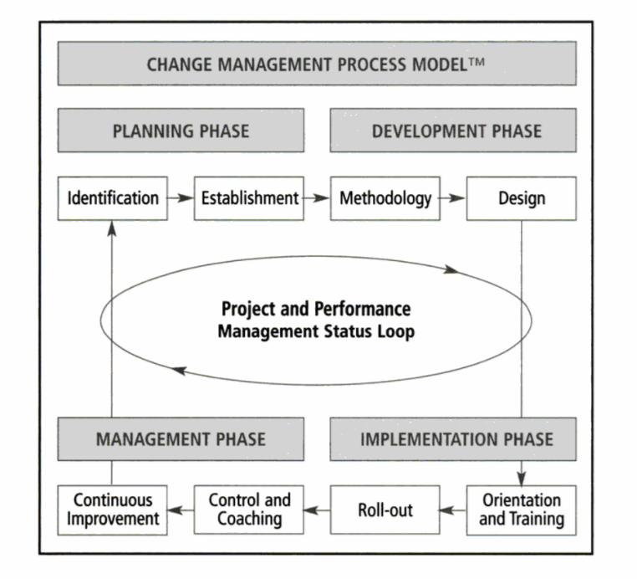

As diagram (Figure 2) shows, each phase is broken down into two steps and each step consists of many tasks.

**1. Phase – PLANNING PHASE**

* **Identification**
  + Establish a steering committee
  + Create long-range and strategic plans
  + Perform assessments and gap analysis
* **Establishment**
  + Budget and cost control
  + A change improvement project
  + A change management team
  + Responsibility assignment
  + Project goals and objectives
  + Key performance targets
  + A project vision statement
  + A mission statements

**2. Phase – DEVELOPMENT PHASE**

* **Methodology**
  + Establish key deliverables
  + Determine objectives
  + Develop strategies
    - a communication and meeting plan
    - a logistics plan
    - a quality document control plan
    - an orientation and training plan
    - training programs
    - a roll-out plan
    - a cost control and project status plan
    - additional work processes
    - job descriptions
    - a continuous improvement plan
* **Design**
  + Workflow charts
  + A reference manual
  + Programs, policies, guidelines and procedures

**3. Phase – IMPLEMENTATION PHASE**

* **Orientation and training**
  + Conduct orientation and training according to the orientation and training plan
* **Roll-out**
  + Roll-out the project

**4. Phase – MANAGEMENT PHASE**

* **Control and coaching**
  + Update the project status
  + Coach individuals and teams
  + Manage additional work
* **Continuous improvement**
  + Implement the continuous improvement plan
  + Identify learned experiences
  + Assign action items (Lister, 2005)

There are many definitions and change management process phases from many authors and publishers. The other authors Ionescu Vladimir-Codrin & Cristina Bolcas (2015) come up with a little bit different Change Management Process Model, but the key message is still the same as previous model has. This model consists of three phases – forecasting, operational and final measurement and interpretation of results. The model is captured in Figure 3.

Figure 3: Change Management Process Model 2 (Vladimir-Codrin & Bolcas, 2015)

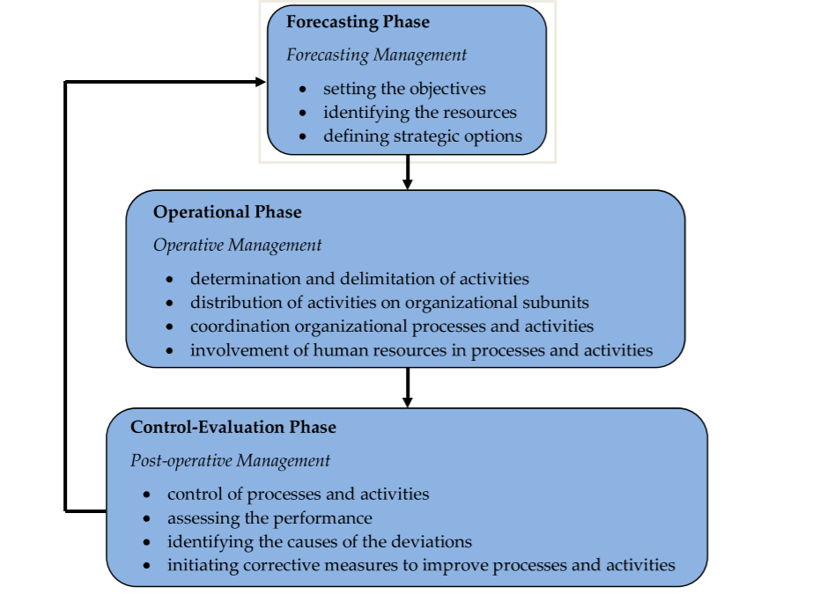

The first phase, in which a **forecasting management** is manifested, involves setting the objectives, identifying the resources and defining strategic options through which the objectives can be achieved, given the resources of the organization.

**The Operational phase** of the change management process, in which an operative management is carried out, includes four steps:

1. Determination and delimitation of activities
2. Distribution of activities on organizational subunits
3. Coordination organizational processes and activities
4. Involvement of human resources in processes and activities.

The third **Control-Evaluation phase**, the measurement and interpretation of results, in which management is post-operative, essentially consists of:

1. Control of processes and activities
2. Assessing the performance by comparison with the level of forecast objectives
3. Identifying the causes of the deviations
4. Initiating corrective measures to improve processes and activities in the next managerial cycle. (Vladimir-Codrin & Bolcas, 2015)

**Planning of change**

Recommended Steps to Manage Change Effectively

* [**Assess the readiness of your organization**](https://www.thebalance.com/employee-readiness-to-commit-to-change-1918698)**to participate in the change**. You can speak with cross-sections of employees to inquire about their support for the changes you propose. Interview other key managers and staff to determine the amount of effort you will need to expend to gain support.  
    
  You can use valid and reliable instruments that are available to help you assess employee readiness for change. You can also obtain qualitative information from internal or external consultants who specialize in organization development.  
    
  Have them obtain the answers to questions such as these.  
  + How much trust exists currently within your organization? Is this enough trust?
  + Do you have a history of open [communication](https://www.thebalance.com/communication-in-the-workplace-1918089) and employee support for change efforts?
  + Do people feel positive about their work environment? Is your culture employee friendly?
  + Do you share financial information? Is communication transparent?
  + Have you experienced a lot of changes and managed it successfully, so your employees are ready to change, and not change-weary?  
      
    These factors have a tremendous impact on whether people will accept and willingly participate in change. If you can build a positive and supportive work environment and culture prior to making changes, you have a great head start on the change implementation working successfully.
  + **Turn the change vision into an overall plan and timeline**, and plan to practice forgiveness when the timeline encounters barriers. Solicit input to the plan from people who **own**or work on the processes that are changing. Otherwise,  you will set your organization up for [unwanted and unnecessary resistance](https://www.thebalance.com/what-is-resistance-to-change-1918240).
  + **Gather information about and determine ways to communicate the reasons for the changes**. These may include the changing economic environment, changing competitive environment, customer needs and expectations, vendor capabilities, government regulations, population demographics, financial considerations, resource availability, and company direction.
  + **Assess each potential impact to organization processes, systems, customers, and staff.** Assess the risks and have a particular improvement or mitigation plan developed for each risk.
  + **Plan the communication of the change.** People have to understand the context, the reasons for the change, the plan and [the organization’s clear expectations](https://www.thebalance.com/what-s-the-big-deal-about-clear-performance-expectations-1919253) for their new roles and responsibilities. Nothing communicates expectations better than improved measurements and rewards and recognition.
  + **Determine the WIIFM (what’s in it for me) of the change for each person** in your organization. Work on how the change will affect each employee directly, and how to make the change fit his or her needs as well as those of the organization.
  + **Some respondents to a survey a few years ago found that the development and sharing of a theoretical underpinning** for the changes was effective in helping individuals understand the need for change.
  + **Be honest and worthy of trust.** Treat people with the same respect you expect from them. (Susan M. Heathfield, 2017)

The following discussion will first use the conceptual framework proposed by [Jarzabkowski and Kaplan (2015)](https://www.sciencedirect.com/science/article/pii/S0007681317301684?via%3Dihub" \l "bib0045) and identify how the scenario-planning tool was selected by a media planning agency for the purposes of developing a long-term corporate level strategy. Second, it will present substantive findings on the application of the scenario-planning tool for the purposes of strategy creation in relation to the media firm, YouTube. Third, it will provide a reflective discussion on the individual and organizational outcomes of using scenario planning within the firm. While there are a number of methodical approaches to operationalizing a scenario-planning project, this study used the approach proposed by [Garvin and Levesque (2006)](https://www.sciencedirect.com/science/article/pii/S0007681317301684?via%3Dihub" \l "bib0015) due to its prescriptive and systematic way of representing future business environments and its ability to help create a long-term strategic direction for a firm.

The scenario-planning process starts with executives considering a key focal issue of strategic importance to the firm and how the future business environment is likely to shape this issue over the long-term. As such, a time frame of 10 years is used to consider plausible and multiple future scenarios and strategic options for the firm. We had one key focal issue for this project: What will be the role of YouTube in the U.K. media industry in 2025?

This issue was of strategic importance to the media planning agency that could see the fast changing business environment created a high level of uncertainty for the firm and its client, and the strategic flexibility of YouTube’s corporate level strategy going forward was of paramount importance. (John J. Oliver, Emma Parrett, 2018)

The key challenges in operations described in the literature have traditionally focused on either i) identifying the potential value of new drugs and assessing their technical performance for selecting research (portfolio or pipeline planning), ii) supporting investment decisions in new capacity (capacity planning) and iii) planning production of the commercialized drug (production planning) ([Shah, 2004; Laínez et al., 2012](https://www.sciencedirect.com/science/article/pii/S0925527314003247?via%3Dihub" \l "bib26)). The problem treated in this paper lies between these planning areas. Portfolio and capacity investment decisions are all taken years before market launch, while production planning considers scheduling production of existing products. In contrast market launch planning considers decision immediately prior to market launch, when the product is almost approved and capacity is available, but before the product is produce regularly.

To avoid contamination in production, the authorities impose strict cleaning regulations on the production equipment. These cleaning requirements lead to long setup times in the order of weeks for the production of the active pharmaceutical ingredient [API]. As a result, long campaigns in which numerous batches are produced for each setup arise, making API production very inflexible ([Grunow et al., 2003](https://www.sciencedirect.com/science/article/pii/S0925527314003247?via%3Dihub" \l "bib14)). These API production plans are largely fixed and cannot be adapted to sudden changes. To plan for API production, aggregated API supply volumes and due dates are needed in advance. Similarly, the procurement volumes of printed packaging material [PPM] and the production volumes outsourced to contract manufacturing organizations [CMO] have to be determined with some notice in advance due to the lead time of these companies and depending on the contractual agreements especially between the outsourcer and contract manufacturing organization ([Boulaksil et al., 2011](https://www.sciencedirect.com/science/article/pii/S0925527314003247?via%3Dihub" \l "bib4)). The final stages of production in which the API is formulated into e.g. pills, put in blister packs and packaged must also be considered. Aggregated formulation and blister production volumes are needed as these production processes also involve campaign planning, which however has a much shorter time horizon than production planning for the API ([Stefansson and Shah, 2005](https://www.sciencedirect.com/science/article/pii/S0925527314003247?via%3Dihub" \l "bib27)). Packaging operations can be changed with short notice, but the capacity of the packaging equipment must however be reserved up front. All of these volumes are needed as inputs into master production planning in secondary production of pharmaceutics. (Klaus Reinholdt Nyuus Hansen, Martin Grunow, 2015)

Not all assumptions of the strategy are of the same importance, but the problem of formulating the vision is raised particularly frequently. Organizations do not operate in an environment, the changes of which can be defined as rational and predictable. The dynamics and complexity of changes also characterize the inside of the company (MacIntosh, Beech 2011). Rapid changes that are uncertain and difficult to predict oblige or even force companies to modify the operations concept (Altiok 2011). In order to confront the changes, it is required to indicate a long-term vision of development. The vision relates to long-term objectives of the company and allows understanding its current and future situation. It must be emphasized that the vision allows planning for the future in a long time horizon. When emphasizing the idea of formulating the vision, it should be indicated that it is impossible to make changes without a vision, because the vision sets the direction for the company (Altiok 2011). This is certainly an important challenge for harmonious development of the company, which is reflected in the management method known as visionary management (Malaska, Holstius 1999).

In this approach a special emphasis is put on the dynamics of visionary leadership (McLarney, Rhyno 1999). Another dilemma that needs to be resolved is the degree of the strategy formalization. In the light of the research on the formalized strategic planning, the definition and implementation of strategic initiatives resulting from the choice of objectives and the degree of formalization of this process are of key importance (Jarzabkowski, Balogun 2009; Mintzberg, 1994; Schwenk, Schrader, 1993; Eisenhatt, Zabaracki 1992). In this case, it seem that importance should be attached not only to the issue of strategic planning but also to the flexibility of planning (Dibrell, Craig, Neubaum 2014; Titus 2011; Wiltbank 2006). (Letycja Sołoducho-Pelc, 2015)

The incentive to working with scenarios is the formulation of company vision. Strategic management vision is understood to be an exact and structured expression of company status in a defined future time horizon. Since the strategy represents a basic planning document, it must be formulated both exactly and consistently in all partial components in order not to lose meaning in its entirety. The planning horizon is usually mid-term but this determination is contingent both upon the character of the business (e.g. pharmaceutical industry, energy industry or capital construction have longer planning horizons) and the development of economic cycle which influences the relevancy of predictions. Even if vision contains all initial information, yet it has to have necessary breadth and depth to become a tool for long-term strategic goals determination. While adhering to these goals and respecting the vision content, strategic grounds are consequently deduced. These grounds describe the requested shift of the company towards target position defined on the basis of all available and known information including demands and attitudes of key stakeholders. It is conditional for the success of scenario elaboration that all important stakeholders concerned would not have objections to scenarios content and their application. The very process of scenario elaboration can be split into six basic steps: Identification of risk factors and determination of their importance. Selection of key risks which, according to the company’s opinion, fundamentally influence fulfilment of strategic goals. Formulation of basic scenarios and testing their consistency. Determination of probability of scenarios occurrence. Performing a “gap analysis” for the sake of determining the extent of strategic goals fulfilment. (Emil Vacík, Jiří Fotr, Miroslav Špaček, Ivan Souček, 2014)

HUMAN RESOURCE DEVELOPMENT QUARTERLY • DOI: 10.1002/hrdq

520 Haeffner, Leone, Coons, Chermack

Maruyama, 2004; Kilduff & Mehra, 1997). Scenario planning is used by an

increasing variety of organizations to organize for uncertain futures in the

spheres of product innovation, nation building, infrastructure development,

and climate change. However, it is more than just a tool to help organizations.

Studies have demonstrated that scenario planning has beneﬁ ts for those who

participate as well; there appears to be a strong link between the scenario

planning method and stakeholder satisfaction (Rowden & Conine, 2005;

Yang, Watkins, & Marsick, 2004).

Wright, van der Heijden, Burt, Bradﬁ eld, and Cairns (2008) acknowl-

edged the virtues of scenario planning, but cautioned that scenario plan-

ning experts could fall into the same trap as their predecessors in strategic

planning by taking vague and ill-substantiated claims as evidence of compe-

tence and effectiveness. In other words, while scenario planning has great

promise as a technique that builds uncertainty into the planning process, rig-

orous research must demonstrate the speciﬁ c beneﬁ ts of scenario planning.

While data-driven studies are increasingly emerging, they remain somewhat

limited by potential sampling errors (Chermack, Lynham & van der Merwe,

2006; Chermack, van der Merwe, & Lynham, 2007). For example, some

experiments use college students in simulated scenarios instead of employees

in businesses facing actual challenges. Although students are readily available

and low cost to recruit into a research study, they may introduce a bias, if they

have an external motivation to participate (a grade, for instance). Further, it is

possible that the scenario experience would differ signiﬁ cantly from partici-

pant to participant because the students come from a variety of backgrounds

and lack a common current issue or decision context.

HUMAN RESOURCE DEVELOPMENT QUARTERLY • DOI: 10.1002/hrdq

520 Haeffner, Leone, Coons, Chermack

Maruyama, 2004; Kilduff & Mehra, 1997). Scenario planning is used by an

increasing variety of organizations to organize for uncertain futures in the

spheres of product innovation, nation building, infrastructure development,

and climate change. However, it is more than just a tool to help organizations.

Studies have demonstrated that scenario planning has beneﬁ ts for those who

participate as well; there appears to be a strong link between the scenario

planning method and stakeholder satisfaction (Rowden & Conine, 2005;

Yang, Watkins, & Marsick, 2004).

Wright, van der Heijden, Burt, Bradﬁ eld, and Cairns (2008) acknowl-

edged the virtues of scenario planning, but cautioned that scenario plan-

ning experts could fall into the same trap as their predecessors in strategic

planning by taking vague and ill-substantiated claims as evidence of compe-

tence and effectiveness. In other words, while scenario planning has great

promise as a technique that builds uncertainty into the planning process, rig-

orous research must demonstrate the speciﬁ c beneﬁ ts of scenario planning.

While data-driven studies are increasingly emerging, they remain somewhat

limited by potential sampling errors (Chermack, Lynham & van der Merwe,

2006; Chermack, van der Merwe, & Lynham, 2007). For example, some

experiments use college students in simulated scenarios instead of employees

in businesses facing actual challenges. Although students are readily available

and low cost to recruit into a research study, they may introduce a bias, if they

have an external motivation to participate (a grade, for instance). Further, it is

possible that the scenario experience would differ signiﬁ cantly from partici-

pant to participant because the students come from a variety of backgrounds

and lack a common current issue or decision context.

HUMAN RESOURCE DEVELOPMENT QUARTERLY • DOI: 10.1002/hrdq

520 Haeffner, Leone, Coons, Chermack

Maruyama, 2004; Kilduff & Mehra, 1997). Scenario planning is used by an

increasing variety of organizations to organize for uncertain futures in the

spheres of product innovation, nation building, infrastructure development,

and climate change. However, it is more than just a tool to help organizations.

Studies have demonstrated that scenario planning has beneﬁ ts for those who

participate as well; there appears to be a strong link between the scenario

planning method and stakeholder satisfaction (Rowden & Conine, 2005;

Yang, Watkins, & Marsick, 2004).

Wright, van der Heijden, Burt, Bradﬁ eld, and Cairns (2008) acknowl-

edged the virtues of scenario planning, but cautioned that scenario plan-

ning experts could fall into the same trap as their predecessors in strategic

planning by taking vague and ill-substantiated claims as evidence of compe-

tence and effectiveness. In other words, while scenario planning has great

promise as a technique that builds uncertainty into the planning process, rig-

orous research must demonstrate the speciﬁ c beneﬁ ts of scenario planning.

While data-driven studies are increasingly emerging, they remain somewhat

limited by potential sampling errors (Chermack, Lynham & van der Merwe,

2006; Chermack, van der Merwe, & Lynham, 2007). For example, some

experiments use college students in simulated scenarios instead of employees

in businesses facing actual challenges. Although students are readily available

and low cost to recruit into a research study, they may introduce a bias, if they

have an external motivation to participate (a grade, for instance). Further, it is

possible that the scenario experience would differ signiﬁ cantly from partici-

pant to participant because the students come from a variety of backgrounds

and lack a common current issue or decision context.

Scenario planning is often used by organizations to think about future uncertainties. However, what it does in terms of changing perceptions is difﬁ cult to assess and quantify. To address this need, this article builds on previous studies documenting the effectiveness of scenario planning. Speciﬁ cally, this article contributes to the data on perceptions of learning organization characteristics. This study compiles quantitative data gathered from 133 individuals working in 10 United States companies who participated in scenario planning. The Dimensions of the Learning Organization Questionnaire (DLOQ) instrument was used in a pre- and post-test research design and differences were analyzed using a t-test. Results show a positive relationship between scenario planning and improved perceptions of learning organization characteristics for six of the seven dimensions of the DLOQ. Interpretation of the results suggests that scenario planning can change participants’ views of their organizations’ adaptive learning characteristics.

As more information becomes available about what could happen in the future, organizations have devised tools in order to organize, disseminate, and assess this information. One such method is scenario planning. We focus on the particular form of scenario planning that involves stakeholders brainstorming their shared visions in an effort to establish adaptive capacity for future uncertainties. It is positioned as a managerial device to address the limitations of more traditional strategic planning methods that are criticized for being prescriptive and reactive. Meanwhile, scenario planning is said to embrace more emergent and proactive views (Mintzberg, Ahlstrand, & Lampel, 2005; Maruyama, 2004; Kilduff & Mehra, 1997). Scenario planning is used by an increasing variety of organizations to organize for uncertain futures in the spheres of product innovation, nation building, infrastructure development, and climate change. However, it is more than just a tool to help organizations. Studies have demonstrated that scenario planning has beneﬁts for those who participate as well; there appears to be a strong link between the scenario planning method and stakeholder satisfaction (Rowden & Conine, 2005; Yang, Watkins, & Marsick, 2004).

Wright, van der Heijden, Burt, Bradﬁ eld, and Cairns (2008) acknowledged the virtues of scenario planning, but cautioned that scenario planning experts could fall into the same trap as their predecessors in strategic planning by taking vague and ill-substantiated claims as evidence of competence and effectiveness. In other words, while scenario planning has great promise as a technique that builds uncertainty into the planning process, rigorous research must demonstrate the speciﬁc beneﬁts of scenario planning. While data-driven studies are increasingly emerging, they remain somewhat limited by potential sampling errors (Chermack, Lynham & van der Merwe, 2006; Chermack, van der Merwe, & Lynham, 2007). For example, some experiments use college students in simulated scenarios instead of employees in businesses facing actual challenges. Although students are readily available and low cost to recruit into a research study, they may introduce a bias, if they have an external motivation to participate (a grade, for instance). Further, it is possible that the scenario experience would differ signiﬁcantly from participant to participant because the students come from a variety of backgrounds and lack a common current issue or decision context. (Melissa Haeffner, Deanna Leone, Laura Coons, Thomas Chermack, 2012)

“Change Management” focuses on strategy and competitive advantage which can be defined as continuous process of synchronization of four key management levers: strategy, operations, culture and rewards (Berger et al, 1993). Approximately any change in structure, technology people or strategies have the potential to disrupt comfortable interaction patterns where effective strategic management process itself can be considered as major changes in organizations and processes (David, 2007:283).

Since globalization has gained importance lately; strategic management and change have become crucial concepts worldwide. In order to gain competitive advantage, organizations should adapt strategies in accordance with changes taking place in their environment (Chandler, 1962). Due to globalization, managers should maintain the congruence of the organization’s strategy, structure and ideology with the demands of an evolving and changing environment (Chandler, 1962; Barker and Duhaime, 1997). By being responsive to changes in environment, some organizations are able to renew themselves whereas some are not able to change or develop themselves. In this study, change process has been accepted as part of strategic management. (Barr, Stimpert and Huff, 1992)

Organizational change can take place from broadest level to narrowest level in institutions. The contents of organizational change are categorized as “change in organization (state)” or “change in strategy (direction)” by Mintzberg and Westley in 1992. An organization can amend its culture and its corresponding strategic vision at the broadest level whereas at the narrowest level, it can alter its people and its operations (Mintzberg and Westley, 1992). The change taking place in an organization is at various level but the “characteristics of change” can vary by level. Change seems to be more strategic when it is more frequent at lower levels. Changes at middle level or below can be depicted as strategic (Mintzberg and Westley, 1992). The definitions of Mintzberg and Westley (1992) for a planned organizational can be seen in the Table below. (Sebnem Penbek, Deniz Zaptcioglu, Mert Gunerergin, 2011)

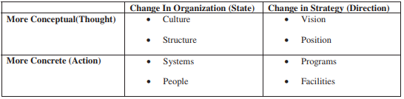

Table 1 Planned Organizational Change

**References:**

Abolhassan, F., Jost, W., Kirchmer, M. & Scheer, A. W. (2003). *Business Process Change Management: ARIS in Practice.* Berlin: Springer

Ajmal, S., Farooq, M. Z., Sajid, N., & Awan, S. (2012). *Role of Leadership in Change Management Process*. *Abasyn University Journal of Social Sciences*, *5*(2), 111-124.

Barcan, L. (2010). *Change Management of Organization in the Knowledge Economy.* Annals of The University of Craiova, Economic Sciences Series, 31-6.

Figliomeni, Carlo. (2012). *Change Management Process for Information Technology*. USA: Xlibris

Kotter International. (2018). *8 Steps to Accelerate Change eBook*. Available at: https://www.kotterinc.com/research-and-perspectives/8-steps-accelerating-change-ebook/

Lister, E. J. (2005). *Successful Change Management*. Canada: Lister Management Inc.

Mento, A., Jones, R. & Dirndorfer, W. (2010) *A Change Management Process: Grounded in both Theory and Practice.* Journal of Change Management. Doi: [10.1080/714042520](https://doi.org/10.1080/714042520)

Pohanková, A. (2010). *Motivation and Decision-Making Process in Managing Change within the Organization.* Human Resources Management. Available at: https://frcatel.fri.uniza.sk/hrme/files/2010/2010_2_10.pdf

Vladimir-Codrin, I., & Bolcas, C. (2015). *Management of Organizational Change Processes*. Manager Journal. Available at: http://manager.faa.ro/en/article/Management-of-Organizational-Change-Processes~834.html

1. HETHFIELD, Susan M. *Use Planning and Analysis to Manage Change Effectively* [online]. 11.11.2017 [cit. 2018-04-16]. Dostupné z: <https://www.thebalance.com/planning-and-analysis-to-manage-change-effectively-1917808>
2. OLIVER, John J. a Emma PARRETT. Managing future uncertainty: Reevaluating the role of scenario planning. *Business Horizons*[online]. 2018, **61**(2), 339-352 [cit. 2018-04-16]. DOI: 10.1016/j.bushor.2017.11.013. ISSN 00076813. Dostupné z: <http://linkinghub.elsevier.com/retrieve/pii/S0007681317301684>
3. HANSEN, Klaus Reinholdt Nyhuus a Martin GRUNOW. Planning operations before market launch for balancing time-to-market and risks in pharmaceutical supply chains. *International Journal of Production Economics* [online]. 2015, **161**, 129-139 [cit. 2018-04-16]. DOI: 10.1016/j.ijpe.2014.10.010. ISSN 09255273. Dostupné z: <http://linkinghub.elsevier.com/retrieve/pii/S0925527314003247>
4. SOŁODUCHO-PELC, Letycja. Planning Horizon as a Key Element of a Competitive Strategy. *Journal of Economics, Business and Management* [online]. 2015, **3**(2), 161-166 [cit. 2018-04-16]. DOI: 10.7763/JOEBM.2015.V3.174. ISSN 23013567. Dostupné z: <http://www.joebm.com/index.php?m=content&c=index&a=show&catid=40&id=458>
5. FOTR, Jiří, Miroslav ŠPAČEK, Ivan SOUČEK a Emil VACÍK. Scenarios and their application in strategic planning. *E+M Ekonomie a Management*[online]. 2014, **17**(3), 118-135 [cit. 2018-04-16]. DOI: 10.15240/tul/001/2014-3-010. ISSN 12123609. Dostupné z: <https://dspace.tul.cz/bitstream/handle/15240/7091/EM_03_14_10.pdf?sequence=1>
6. HAEFFNER, Melissa, Deanna LEONE, Laura COONS a Thomas CHERMACK. The Effects of Scenario Planning on Participant Perceptions of Learning Organization Characteristics. *Human Resource Development Quarterly* [online]. 2012, **23**(4), 519-542 [cit. 2018-04-16]. DOI: 10.1002/hrdq.21147. ISSN 10448004. Dostupné z: <http://doi.wiley.com/10.1002/hrdq.21147>
7. BARR, Pamela S., J. L. STIMPERT a Anne S. HUFF. Cognitive change, strategic action, and organizational renewal. *Strategic Management Journal* [online]. 1992, **13**(S1), 15-36 [cit. 2018-04-16]. DOI: 10.1002/smj.4250131004. ISSN 01432095. Dostupné z: <http://doi.wiley.com/10.1002/smj.4250131004>
8. PENBEK, Şebnem, Deniz ZAPTÇIOĞLU a Mert GÜNERERGIN. The need of effective strategic management during a planned change: An example of bologna change process from a Turkish university. *Procedia - Social and Behavioral Sciences* [online]. 2011, **24**, 649-662 [cit. 2018-04-16]. DOI: 10.1016/j.sbspro.2011.09.071. ISSN 18770428. Dostupné z: <http://linkinghub.elsevier.com/retrieve/pii/S1877042811015990>