**1. What do you say to express the situation in the picture? Tick the right option(s) ( / 8):**

|  |  |  |  |
| --- | --- | --- | --- |
| https://img.clipartfest.com/5112794178c98661fa240226357e2228_cartoon-of-woman-picking-up-a-heavy-cartoon-woman-clipart_882-1300.jpeg | Výsledek obrázku pro timetable train | Výsledek obrázku pro  shopping bag with tomatoes clipart | Výsledek obrázku pro kickoff football clipart |
| Wait, I’m going to help you. | The Helsinki train is going to leave at 04:18. | Oh, you are going to make vegetable salad. | Who do you think is going to win? |
| Wait, I’m helping you. | The Helsinki train is leaving at 04:18. | Oh, you are making vegetable salad. | Who do you think is winning? |
| Wait, I’ll help you. | The Helsinki train will leave at 04:18. | Oh, you will make vegetable salad. | Who do you think will win? |
| Wait, I help you. | The Helsinki train leaves at 04:18. | Oh, you make vegetable salad. | Who do you think wins? |

**2. Complete the following conditional sentences ( / 12):**

1. Come on, John! You _______________ (miss) the train if you _______________ (not hurry).
2. Shame, I don’t have enough money. If _______________ (have), I _______________ (buy) a new speakers.
3. It’s raining, so we’re not going out. We _______________ (get wet) if we _______________ (go out).
4. I must go and see Ann sometimes. Actually, if I _______________ (have) time, I _______________ (go) today.
5. It’s not a very nice place. I _______________ (not go) if I _______________ (be) you.
6. If the weather _______________ (be) right, we _______________ (always go) for a trip in the mountains.

**3. Finish the sentences in an appropriate way ( / 8):**

1. If I won a million, ______________________________________________________
2. If the roads are wet, _____________________________________________________
3. If I graduate this year, ___________________________________________________
4. I get very tired, if _______________________________________________________

**4. Make responses as indicated. Write more options where possible: ( /12):**

1. “I have never been to India” - You (-) : “ “
2. “She’s got a dog” - You (-) : “ “
3. “They will get married sometime” - You (+): “ “
4. “I don’t understand!” - You (+): “ “

**5. Correct the errors: ( /12):**

1. Do you go at the party in Saturday, if they invites you?
2. I have arrived to Russia 2 years ago.
3. She have ever been in India.
4. She’s visited them yet.
5. Look at those cloud. It will rain.

**6. Put in a relative pronoun where necessary: ( /10):**

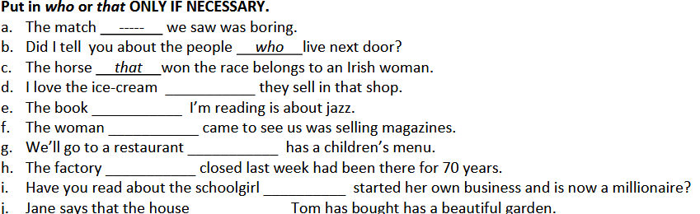

**7. Describe the following people. What do they look like? ( /16):**

|  |  |
| --- | --- |
| Výsledek obrázku pro girl wearing a blouse, skirt, tights boots |  |

|  |  |
| --- | --- |
| Výsledek obrázku pro tall man in a suit and bowtie umbrella trainers |  |

|  |  |
| --- | --- |
| Výsledek obrázku pro curly hair women, jumper, gloves, jeans |  |

|  |  |
| --- | --- |
| Výsledek obrázku pro curly woman, tracksuit, trainers |  |

**8. Correct the errors in these sentences. ( /12):**

a. Joan won the prize, that surprised me a lot.

b. The children, that were playing football, broke one of my

windows.

c. The house in that I was born has just been demolished.

d. Fred is the man who he live s next door.

e. The books which they are on the table are mine.

f. I can’t remember the name of the person from who I borrowed this pen.

**9. Label with the correct word ( /10):**

 _________________ ______________________

   