

Macroeconomics 2

Moodle blocks 6

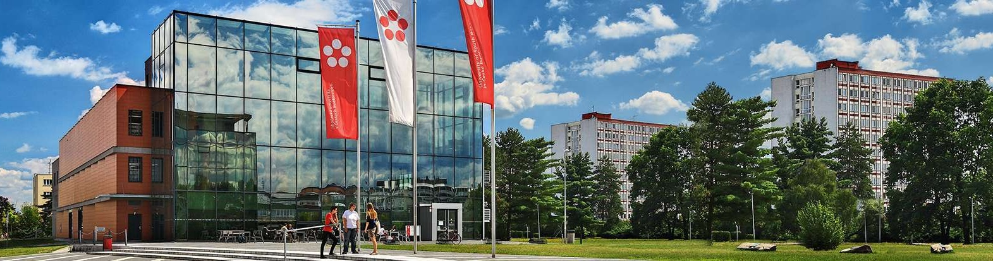

Jihočeská univerzita v Českých Budějovicích

Branišovská 1645/31a

370 05 České Budějovice

IČ: 60076658

# Model IS (in the three-sector model of the economy)

TAt = t*Y + TAa

Y = AD

Y = Aa + c(1-t)Y – bi rovnice IS **Y = α 3 * ( Aa3 – bi )**

What are the main causes of foreign trade?

What the IS curve shows to us?

Explain how the multiplier **α** and the sensitivity of investment (autonomous expenditures) to interest rate (b) affect the slope of the IS curve and who influences the position of the IS curve

The economy is characterized by the following data

C = 100 + 0,8 Y I = 400-2000 i Ga = 500 t = 0,25 TRa, TAa = 0

a) specify the amount of autonomous expenditure

b) Identify the IS equation

c) Determine the equilibrium production level for i = 16% i = 8%

Economic data are Ca = 120, c = 0,60 I = 300-3000 i, Ga = 400, Tra = 0

TAt = 100 + 0,2 Y (TAt = TAa + t * Y)

a) Specify the equation of the IS curve

b) Determine the slope of the IS curve

c) Graphically illustrate an IS shift if government spending increases by 100 units

Write the IS equation with variables i and Y for consumption function C = 600 + 0,75YD and investment function I = 800 - 1600i, Ga = 200, t = 0,25, TRa and TAa = 0

find out:

(a) its equilibrium NH value of the product at i = 0,05

(b) how the NH product and the IS graph change if:

• Increase the investment sensitivity parameter to interest rate to 2000

• Increase the threshold for consumption to 0.8 and I = 800-1600i

• The autonomous investment will increase to I000 and C = 600 + 0.75Y