

Macroeconomics 2

Moodle blocks 1 + 2

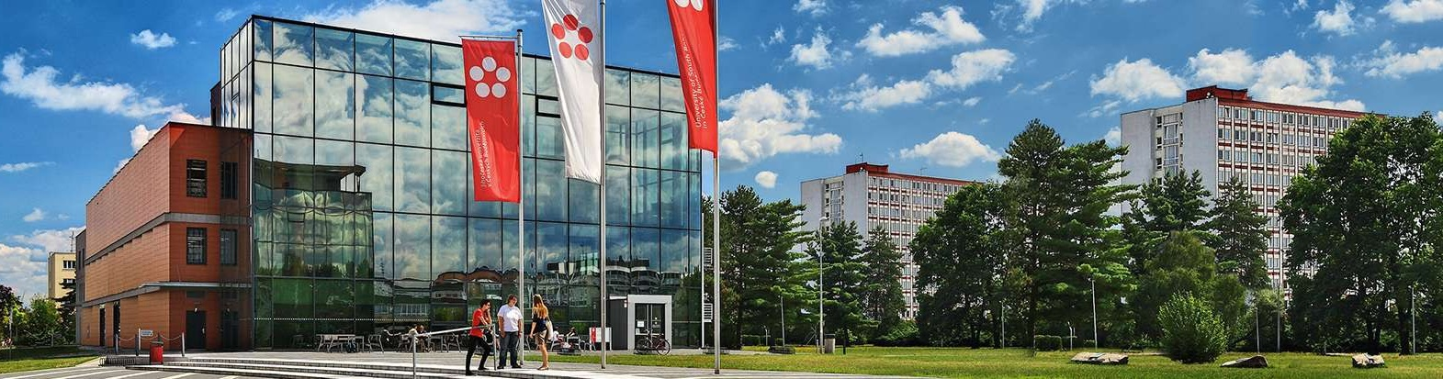

Podtitul dokumentu

Jihočeská univerzita v Českých Budějovicích

Branišovská 1645/31a

370 05 České Budějovice

IČ: 60076658

# Macroeconomics MOODLE blocks 1 +2

**(Two-sector model of economy)**

Y = C ( consumption) + I (investment) Y = C (consumption) + S (savings) I = S

C = Ca (autonomous consumption) + c * Y Y = AD (production is in equilibrium if = AD

S = - Sa (autonomous savings) + s*Y α 2= 1/ (1-c) = 1/s

I = Ia (autonomous investment ) - b*i b = coefficient of interest rate demand sensitivity

APC (average propensity to consume) = C/Y

APS (average propensity to savings) = S/Y

1. From what basic entities consists a two-sector model of economy?
2. Illustrate graphically the consumption function C = 500 + 0,6Y
3. What is the difference between the marginal and the average propensity to consumption?
4. Let us consider the economy in which only the household and business sectors exist and where the development of the following variables has been measured (GBP billion):

                        disposable income (Yd) Household savings (S)

                                     1 600 150

                                     2 000 250

                                     2 400 350

                                     2 800 450

a) Write the equation of consumption function for this economy

b) Determine the amount of autonomous savings and savings if the product amount will be 3000

c) Graphically illustrate the savings function of the point b)

1. Determine the equilibrium level of income in a specific country, where only households and firms operate, if the consumption function is C = 500 + 0,8Y and the amount of investment is I = 500. Graphically illustrate this situation in a 45 o model.
2. The economy of an independent beer state in which only two entities operate is characterized by the following variables: consumption function S = -100 + 0,25Y and the investment is I = 200. The economy is closed without the influence of state activities.

a) assemble the function of consumption (C = Ca + c Y)

b) what is the level of the equilibrium product

c) calculate the average propensity to consume

d) from what amount of NH product the household will start to save

e) graphically illustrate the situation from point d) in the consumption function of model 45 o

f) determine from which amount of product will manufacturers produce more than the AD requires

1. In a two-sector economy, the planned investment expenditure will increase by $ 70 billion. The product then rises to a new equilibrium level. The marginal propensity to consume from disposable income is 0,9. Calculate how much (%) will the consumption expenditure change.
2. The economy is characterized by the following variables: consumption function C = 100 + 0,75 Y and investments are I = 300

a) what is the equilibrium level of the NH product

b) how much (%) will change the equilibrium level of NH product if the investments increase to I = 400

c) We assume that consumer behaviour has changed. The consumption function will be C = 100 + 0,8 Y and investment expenditure will remain 300. Will the equilibrium level of the NH product be higher or lower?

1. The economy of a hedonistic state in which only two entities operate is characterized by the following variables. Autonomous consumption is equivalent to 400 billion, the product is at the level of 6,000 billion, and the amount of investment is 800 billion.

A) calculate the average propensity to consume

B) find out the value of how will the product increase if autonomous consumption increases by 30%

C) find out how much (%) will change consumption in the previous situation B)

D) graphically illustrate point b in the two-sector model 45