**Excercise - Power BI – Data**

1. Import data from the feed Now http://services.odata.org/V3/Northwind/Northwind.svc/
2. Select the Customers and Orders tables for import
3. In the Customers table, preserve the ContactName, City, Country columns
4. In the Orders table, expand the ContactName column from the Customer link
5. In the Orders table, expand the Quantity_and UnitPrice columns from the Order_Details link
6. In the Orders table, calculate the total price for each order line
7. In the Orders table, perform the Customer.ContactName grouping and calculate the amount for all customer orders
8. Create a relationship between the Orders and Customers tables
9. Create a visualization with an overview of the state, customers from the state and the amount for their orders

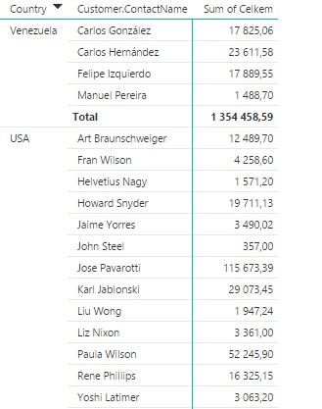

1. Try to figure out what you might use, or edit your report (by country, by city, or otherwise) and try to think about the use of this report

